
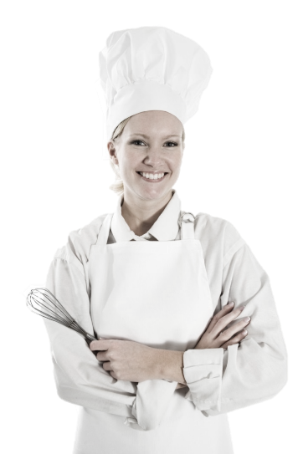

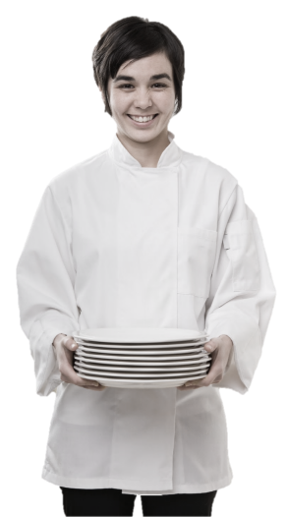
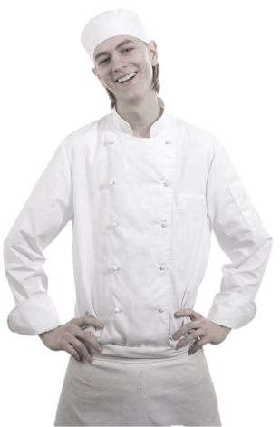

Bartender / Bake Staff
Training Manual

2019

Employment Policies and Procedures
Standard Operating Procedures
Table of Contents
Introduction
Alcohol Awareness
- The Law
- Intoxication Behavioral Cues
- Identification Request or "Carding"
- Acceptable Forms of ID
- Steps To Checking ID

Safety & Sanitation
- General Policy
- Beverage Service
Guest Care
- Never Underestimate the Importance of a Guest
- You Must Be Able To Serve Many Different Types Of Guests
- Five Basics of Service Excellence: From the Perspective of the Guest

Personal Appearance
- Uniform
- Dining Room Dress Code
The Greeting
Register Operations
BAR --------------------
Bar Station Setup
- The Well
Back Station Setup
- Hot Drink Station
Service Well
- Server Responsibilities
- Bartender Responsibilities
- Drink Basics
- Recipe Adherence
Standardization of Beverage Orders
- Preparing Drinks
Glassware
- Proper Glassware
Ice
Drink Making Techniques
- Build
- Stir & Strain
- To stir and strain a drink:
- Shake & Strain
- Blend
- Layer
- Float/Top
- Muddling
- Eye Appeal
Garnishes
- Quality Hints
Bar Cleanliness
BAKE STATION RESPONSIBILITIES --------------------
rAW MATERIAL
- Premixing
- Mixing
PREMIXING & MIXING, FERMENTATION, HANDLING OF BULK DOUGH
- Procurement
- Storage
DIVIDING AND PREPERATION OF INDIVIDUAL UNITS
BAKING, COOLING, & FINISHING
PACKAGING AND STORAGE OF FINISHED PRODUCT
SLICING/PACKING OF BREAD AND CONFECTIONARY PRODUCTS
RETAIL AND DISPLAY
Closing Out A Table
- Presenting the Check
- The Farewell
- Methods of Payment
Opening & Closing Duties
- The weekly clean up
End of Shift Responsibilities
- Proper storage procedures
- Cleaning responsibilities
Security Responsibilities
Check-Out Procedures
- Before You Start the Paperwork Process
- Accountability Process
- Gift Certificates
- Cash
- Zeroing Totals
- Time Out
- Tip Declarations
Performance Standards
- You Should Not
- Checking Identification
- Doubles
Conclusion

Introduction
Congratulations on being selected to perform one of the most important, challenging and rewarding jobs at the Maple Leaf Diner!
As a Server, you will set the stage and have a direct impact on each guest's experience. You will determine whether each guest feels welcome, appreciated and well cared for.
We will provide you with the training you need to be successful. We take great pride in our quality food and friendly, responsive service. Our high standards can only be maintained through great people like you who share our values and desire to do the very best job possible for our guests every day.
As a server, it is essential that you maintain an energetic, friendly and caring attitude at all times. It is your responsibility to see that each guest is made to feel special and enjoys our fun atmosphere and great food and beverages.
The guidelines listed on the following pages have been established to help you in your effort to provide these qualities to our guests. Along with the hands-on training you will receive, this manual will provide answers to questions you may have regarding your tasks, responsibilities and operating procedures.
Once again, welcome to the Eh-Team!

Alcohol Awareness
The Maple Leaf Diner is committed to serving alcohol responsibly. Managers and staff must take all reasonable steps to prevent underage drinking, alcohol over consumption and to prevent our guests from driving while under the influence of alcohol. The reputation of our restaurant is at stake.

The law
The legal drinking age is 21 in all states.
Third party liability laws read that the server of alcohol and the restaurant establishment are held liable when a guest consumes alcohol, leaves the premises and then cases injury or death to himself or someone else. The law requires that a server make reasonable effort to prevent intoxication in guests, prevent alcohol sales to minors and intervene if a guest does become intoxicated.

intoxication behavioral cues
- Inhibitions – Becomes talkative, relaxed, over-friendly, loses self-control, and sometimes displays mood swings.
- Judgment – Behaves inappropriately, such as ordering doubles at last call, uses foul language, tells off-color jokes or annoys others.
- Reactions – Classy, unfocused eyes, talks or moves very slowly, forgets things, slurred speech.
- Coordination – Stumbles or sways, drops belongings, has trouble picking up a drink.

Identification request or “carding”
As a bartender and/or server, you must make certain that the person you are serving to is of legal age.
Anyone that appears under 30 years of age is required to have a valid ID
Notify a manager immediately if guests have any problems with this request.

Acceptable forms of id
- Valid driver’s license
- Valid state-issued ID card
- U.S. active-duty military ID
- Valid Passport

Steps to checking id
- Ask the guest to remove the ID from his/her wallet.
- Determine whether the ID is valid by:
  - Checking the birthdate
  - Checking the expiration date.
If you suspect a problem or discrepancy with the identification offered, get a manager immediately.

Safety & Sanitation

General Policy
The responsibility of management and staff to protect the public from food borne illness is fundamental.
A food borne illness is simply a disease that is carried, or transmitted, to human beings by food.
Throughout your training, you will receive information concerning proper temperatures of food storage and serving, as well as, cleanliness standards, proper use of chemical cleaning, and disinfectant products. It is our objective to operate the restaurant at the highest level of cleanliness and sanitation for the benefit of our customers and employees. Refer to our safety and sanitation policies in the Employee Handbook.

Beverage Service
- Always use a designated ice scoop (Never use a glass to scoop ice).
- Always store ice scoops in a desingted container.
- Always use the deesinated tongs to retrieve lemon wedges.
- When refilling beverages, never touch the guests glass or straw to the pitcher.
- When refilling beverages at the soda station, ensure that the straw never touches the soda and nozzle.
- Always store ice bickets inverted on a hook. They should never be sotred directly on the foor.

Guest Care
Our function as a Restaurant is to acquire and maintain business, and to turn casual customers into loyal, repeat guests.

Never underestimate the importance of a guest!
- A guest is not dependent upon us -- we are dependent upon him (or her).
- A guest is NEVER an interruption of our work - he is the purpose of it.
- A guest is the lifeblood of our restaurant.

Five Basics Of Service Excellence: From the Perspective of the guest
- Look at me.
- Smile at me.
- Talk to me.
- Listen to me.
- Thank me.

You Must Be Able To Serve Many Different Types Of Guests
To make appropriate selling suggestions, and give good service, it is helpful to recognize and know how to handle all types of guests. For example:

The Timid Guest: | Genuine interest and patient understanding will put this type of guest at ease. Even a comment on the weather can make him feel at home.
The Aggressive Guest: | This type must be handled in a courteous and businesslike manner. Kindness and politeness can often change him into a steady and appreciative customer.
The Fussy Guest: | This is one of the hardest guests to please. Try to stay one step ahead of him by learning the things that irritate him. Be sure to have everything just right, before serving the fussy guest. Remember all of the little things the fussy guest especially likes, even when they may seem peculiar to the average person.
The Over-Familiar Guest: | Be courteous, dignified, and avoid long conversations. Stay away from the table, except when actual service is needed. Never try to give a wise crack answer to a smart remark. You will only cheapen yourself and lower yourself to the same level as the rudeness of the guest.
The Guest Who Is Alone: | Don't call attention by asking if he is alone. Seat him where he can see what is going on. The guest may be lonely and want someone to talk to. Be friendly, but don't neglect other guests. With nobody to talk to, time seems long, so serve as quickly as possible. This could be your most critical guest.
The Noisy Trouble-Maker: | Don't be drawn into arguments. Speak softly. Don't antagonize. Refuse to participate in criticism of management, the establishment, or other personnel.
The Blind Guest: | Seat blind people with a dog so that the dog will not be noticed. Never hover over blind customers. Always stand near enough to help if needed. Issue menus in Braille to the blind guest. Always make a blind customer feel appreciated and important.
Guest With Hand Or Arm Injuries/Disability: | Seat as quickly as possible. Be helpful, ask if you may assist them, but do not be too eager. Be considerate; do not call attention by hovering. Seat wheelchair guests at a table on ground level do not block an aisle. Always make a disabled guest feel important and accommodated.

Personal Appearance
Your overall image is our image. You make a distinct impression on each of our guests. The image you create can enhance or detract from our overall concept and the way our Restaurant is perceived in the minds of the guest. You are entrusted with handling our guests' needs and must, therefore, reflect cleanliness and wholesomeness at all times. Always remember . . .
- You are responsible for keeping your uniform neat and clean at all times. There is no excuse for reporting to work out of uniform.
- A smile is part of your uniform.
- Do not report to work with an un-pressed or dirty uniform, or un-kept hair.

Uniform
When you walk through the front door of the Restaurant, "YOU ARE ON.” You will be informed of the uniform requirements when you start with us. Your designated uniform also includes a CONTAGIOUS, ENTHUSIASTIC ATTITUDE. You are required to enter the building for your shift in FULL UNIFORM. You are also required, when you leave the building, to be in FULL UNIFORM.

Dining Room Dress Code
Shoes – Clean solid black shoes (no colored stripes or logos) designated by the manufacturer to be slip-resistant or skid resistant. Must be closed toe and closed heel (no clogs). Socks must be black.
Pants & Belts – Clean professional looking, wrinkle-free black slacks / pants (dry cleaning / creases not required). Pants must be long enough to cover shoe tops. Lycra / polyester stretch knit, corduroy and linen pants are not acceptable and may not be worn. No rolled cuffs and no large pockets. Black belt or no belt.
Shirts – All shirts must be clean and wrinkle free. Black Maple Leaf Diner T-shirt or solid black t-shirt that is not faded and at least medium-weight material. The material must be thick enough, so it is not transparent.
Accessories - No cologne or perfume No excessive make-up or jewelry. No earrings longer than 1 inch. No hats.
Apron – Maple Leaf aprons must be purchased for $15.
Miscellaneous – Please have a wine opener, lighter and at least 2 pens at all times.

The Greeting
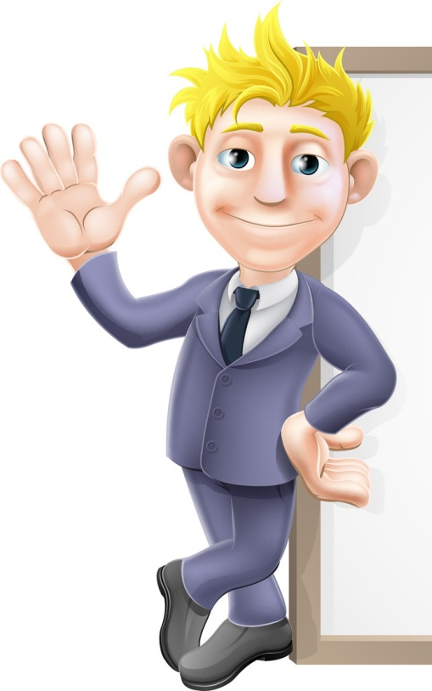
Your greeting is the first impression given to the customer, so strive to make it special. Always greet the guest with a smile, a welcome, and your name. Demonstrate some aspect of your personality. Change it around: using the same greeting every time sounds mechanical.
Approach your guest(s) as soon as possible. If you can't get to a new guest within 30 seconds, be sure that you at least acknowledge them by eye contact and verbal contact. The first thought going through a guest's mind is, "Am I going to be waited on?" You can notice the person visibly relax when you say, "I'll be right with you."

Register Operations
You will receive training on our computerized register system. It is equipped with imprinters that will send food items to the kitchen and bar items to the bar. The register system imprints time of order, bar seat number, and date. It is extremely important that you fully understand the register operations, to eliminate food or beverages going out at wrong times and to the wrong tables; and, wrong food being made and sent out.
This system will also allow you to close out methods of payment for cash or credit cards. This system is designed for the server's ease and comfort and enables them to remain on the floor and in their stations.
It is important for the server to be fluent in register operations for many reasons:
Organization and speed in the kitchen
Waste control
Expedience

The best customer service and experience

Bar Station Setup

The Well
The well station is set up at each location behind the bar. This station is designed to maximize the bartenders' speed and efficiency in preparing commonly ordered drinks.
Each highball station should be set up in the same manner so that bartenders are not searching for product as they move around the bar.
Guidelines for this station include:
Cubed ice in the bin with the ice scoop placed in a clean container.
Mixer and soda gun on the right-hand side of the station.
Mixing mat placed in the rail, 2 mixing tins, and the bar strainer to the right.
Bar spoon in a designated area.
All necessary garnishes in their proper containers (limes, etc.)
Straws, napkins in the napkin holder - organized and in easy reach.
Well liquors, arranged in a specified order, located in a speed rail attached to the ice bin.
Lime mix and Grenadine in the speed rail.
Most frequently used call liquors located at every station in the speed rails.
Glassware stored in its designated area at each station.
Stemware located so that it is accessible from every station.
Trash receptacle nearby.
6-Packs in a central, convenient location for all bartenders.
Condiments in a central convenient location for all bartenders.

Back Station Setup

Hot Drink Station
2 burner hot plates (set on medium) with two coffee pots (one for coffee, one for hot water).

Sugar and Sweet n' Low in plastic containers.
Footed glass cups in easy reach
Tea bags
Garnishes:
Lemon twists
Sugar for rimming
Whipped cream
Liquors and liqueurs for hot drinks in the nearest speed rail (bottles are grouped by drink recipe where possible).

Service Well
Servers will order beverages for guests at tables through the bartender at the service well.

Server Responsibilities
Servers work as a team with the service bartender to ensure that drinks are prepared for our guests in the most efficient manner.

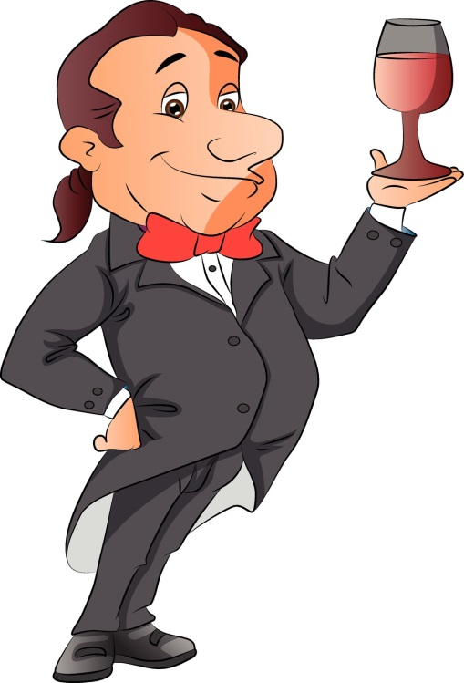
Servers Are Responsible For:
Garnishing drinks

Bartender Responsibilities
The service bartender is responsible for:
Preparing drinks.
Teaching servers when mistakes are made in price, glass, or garnish.
Always use two hands to do several things at one time.
Service well is your main priority (keep servers happy).
The bartender working the service well is the bartender who pours drinks for the servers. Servicing the servers' needs is the service bartender's top priority.
When busy with bake duties and responsibilities: recognize the customer first, but serve the servers first.

Drink Basics
Cocktails contain two types of ingredients and may contain a third. They are:
Base
Modifying, smoothing, or aromatizing agent
Special flavoring and coloring ingredients

Base
This is the fundamental ingredient. It makes up at least 50% of the cocktail. Normally, the base consists of a single liquor, which determines the type of cocktail. There are gin cocktails (Martini), whiskey cocktails (Manhattan), rum cocktails (Daiquiri), etc.
It is possible to combine two (or more) liquors as a base. For example, rye and bourbon whiskeys, while different in flavor, have the same characteristics and can be used interchangeably or in combination as a base. Gin and white rum also blend well.

Modifying Agent
This ingredient smoothes down the biting sharpness of the raw liquor and adds character to its natural flavor. The modifier flavor should never predominate over the liquor flavor.
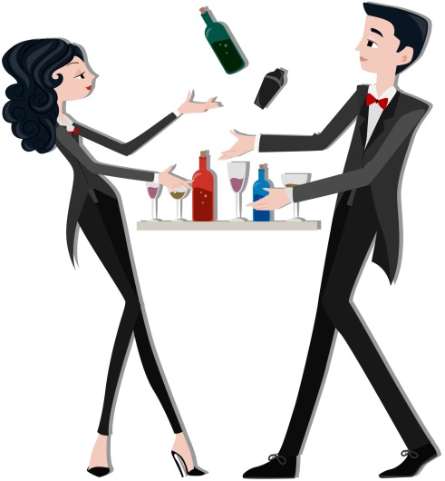
There are three classes of modifying agents:
Aromatics - vermouth, bitters, Dubonnet
Fruit Juices - orange, lemon, lime, etc., with or without sugar
Miscellaneous - "smoothing" agents such as sugar, cream, eggs, etc. Cream and eggs produce a creamy, foamy drink that is pleasing to the eye, as well as pleasant tasting.

Special Flavoring & Coloring Agents
These include fruit syrups as well as cordials or liqueurs. An ingredient that is used as a modifier in one cocktail may be used as flavoring or coloring in another.

Recipe Adherence
Your guests expect to receive a consistent, great tasting drink every time they visit. In order to maintain a high level of consistency and guest satisfaction MLD has carefully developed written recipes for all drinks.
Every recipe has been thoroughly tested to ensure that the quality meets our guests' expectations. Take pride in adhering to the recipe 100% of the time.
Strict recipe adherence will involve focusing on the following areas:
Glassware
Ice
Liquor Pouring
Drink Making & Techniques
Eye Appeal
Mixes
(This may be waived, after you pass a free pour test)
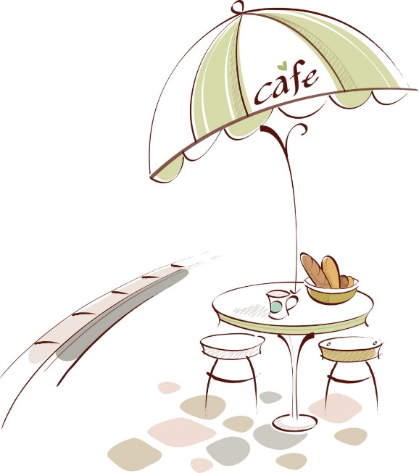

Standardization of Beverage Orders
Well liquors - are used when the guest does not specify a particular brand to use: i.e., bourbon and Coke.
Call liquors - are used when a guest specifies a particular brand of liquor for the drink: i.e., Jack Daniel's and Coke.
Premium liquors - are liquors with a specific brand name, but are either aged or imported, and therefore, are more expensive: i.e., Crown Royal and Coke. This would include the Super Premium liquors.
Also, when ordering a drink that is to be prepared on the rocks, order it as such. If a customer orders a Stoli on the rocks, order "Stoli rocks." The bartender will then pour 2 oz. of that liquor. This does not include drinks that contain a "splash" of a mix. These get ordered normally, and get an ounce and a quarter shot.

Preparing Drinks
Consistency of product is a vital part of our professionalism. A drink prepared by one bartender must be prepared exactly the same way by all other bartenders. Therefore, it is essential that you study and learn the drink recipe manual and any specialty or regional drink recipes.
If you do not know a recipe, look it up in the recipe book. If the drink is not listed, ask the guest if he or she knows the ingredients. Often, the same drink is called by a different name in different locales.
Always line up your tools and ingredients before beginning. A drink that stays in the shaker while you get a glass will be less than the best. Pour drinks accurately, using your jigger. Whenever possible, mix drinks within the guest's sight with the label pointing toward the guest.
Return all liquor or other ingredients to their proper place after using them. This speeds up service by ensuring the item can be found quickly and easily for the next drink. After using any mixing time, always rinse and wash before returning it to its proper storage place. The tin will be ready for the next drink.

Glassware
There are three basic rules concerning glassware:
- Use the proper glassware for each drink.
- Ensure that glassware is sparkling clean.
- Ensure that glassware is not cracked or chipped. (Always use an ice scoop; this will prevent glassware from chipping and cracking. This is also a safety measure).

Proper Glassware
Glassware is specified on each drink recipe. Always use the correct glass. This ensures the correct ratio of liquor to mixer. All of our recipes were developed specifically for our glassware.
Unless specified in the recipe as pre-heated or pre-chilled, glassware must be at room temperature. Glassware just out of the dish machine is too hot to use. Adding ice to a hot glass will cause breakage.

Chilled Glassware
A glass is chilled when used to serve a cold beverage with no ice.
To Chill a Glass: Fill the glass with cubed ice, and then with seltzer. Allow to sit while preparing the drink, then discard ice and water. Shake out excess water and pour the cocktail. Do not return ice and water to the ice bin.

Pre-Heated Glassware
A glass is pre-heated when used to serve a hot drink or aromatic liqueur.
To Pre-Heat a Glass: Fill the glass with hot water and allow to sit until hot to the touch, then pour hot water back into the pot.

Ice
90% of the drinks you make use ice in some form.
Ice is a food product and is consumed by your guests. It is treated with the same sanitary procedures as any food item in our Restaurant.
- Always ice glasses with an ice scoop. Never use your hands or scoop a glass through the bin.
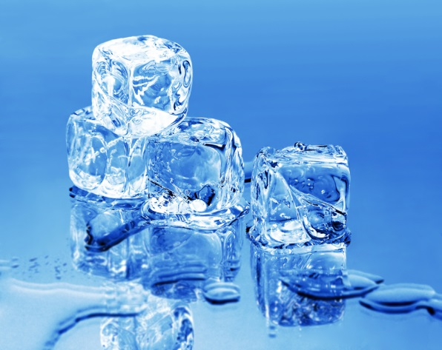
- Glasses should never be placed in ice. You might break the glass in the ice.
- Ice must be hard and clear. Your management staff has a regular maintenance program for the ice machines to ensure that they work properly and provide the correct product.
- Ice must be cold. Ice may vary in temperature from -10 F to +32 F. "Warm" ice melts quickly and makes weak, diluted drinks.
- Ice must be dry. Ice should stay dry. The ice bins should have adequate drainage to allow melting water to drain off easily and quickly. Check ice bin drains at the ice machine, service bar, and front bar at least one a week.
- Ice must be clean. Keep all impurities out of the ice. Some bars store fruit, bottles, and cartons in the same ice used to mix drinks. Health departments regard such ice as contaminated, and you should, too. Ice bins and ice scoops should be included in a regular clean-up program.
- Use plenty of ice when making drinks. Unless specified by recipe, all glasses should be packed with ice before a drink is made. This ensures the proper ratio of liquor to mixer. The correct amount of ice also prevents over-dilution. Dilution is the water from melting ice, and is part of any drink. However, excess dilution spoils the drink.
If you break a glass near or over an ice bin, take that ice out of service immediately! Do not take a chance with your guests' safety. Broken glass in ice is extremely hazardous.

Drink Making Techniques
All of our drinks are made using one of the following techniques:
The correct procedure will be specified in the recipe.

Build
When building a drink, the ingredients are poured directly into the glass in which it is served (with or without ice). Building is the easiest drink-making technique (used for highballs, juice drinks, nails, and hot drinks).

Stir & Strain
This technique is used to chill a clear liquor/liqueur or combination of liquors/liqueurs when they are served straight up.
Stirring mixed ingredients, assures proper dilution, and chills liquor to the proper serving temperature. Clear liquors are stirred and strained, instead of shaken and strained, to maintain the crystal clarity of the liquid.
If a clear liquid is shaken or mixed, it becomes mixed with air and looks cloudy.

To stir and strain a drink:
- Fill a mixing glass with ice.
- Pour ingredients into the mixing glass.
- Stir quickly 8 to 10 times with a bar spoon until condensation forms on the outside of the glass. DO NOT CHURN.
- Fit a bar strainer over the mouth of the mixing glass and strain the liquid into the proper glass. Never use your fingers to strain a cocktail.
- Wash the mixing glass, strainer, and bar spoon.

Shake & Strain
This technique is used with opaque ingredients (juices, sweet & sour mix, cream).
Shaking and straining accomplishes the same result as stirring and straining, but also produces a froth from the mixture and provides a good show for the guest.
To shake and strain a drink:
- Fill a mixing glass with ice.
- Pour ingredients into the mixing glass.
- Fit the mouth of a mixing tin over the mouth of the mixing glass at an angle.
- Rap mixing tin firmly downward onto the mixing glass to create a seal.
- Hold the base of the mixing glass in one hand and the base of the mixing tin in the other hand. Vigorously shake until a frost appears on the mixing tin.
- While holding the mixing tin and glass, as in Step #5, gently tap the protruding edge of the mixing tin against the shot rail to break the seal between the tin and the glass. Lift the tin off.
- Fit a bar strainer over the mouth of the mixing glass and strain the mixture into the proper glass.
- Wash the mixing glass, tin, and strainer.

Blend
A blending technique is used to liquefy solids. Frozen and ice cream drinks are blended to a slushy or creamy consistency. There should be fluid enough to pour, yet thick enough to hold a straw upright.
To blend a drink, follow these instructions:
- Place ingredients into the blender cup, and then add ice.
- Firmly set blender cup on base/motor. Place the top on the blender.
- Set speed to "low" (draws ingredients down into blades and extends the life of the blades, clutch and motor). Turn motor "on."
- To produce a fully blended drink, after ingredients are incorporated, switch speed to "high" until the blending is smooth.
- Switch speed back to "low", turn off motor, allow blender to slow, and remove blender cup (this extends the life of the blades, clutch and motor).
- Pour the mixture into the proper glassware.
- Wash the blender.

Layer
Layering is used to produce distinct "layers" of ingredients with clear and sharp separation of one layer from another.
Each ingredient is poured so that it "sits" atop the preceding ingredient, with no mixing of the two.
To achieve this effect, follow the ingredient order listed in the recipe.
- Pour first ingredient into the glass.
- Place bar spoon atop first "layer" so that the bowl of the spoon rests on the surface of first "layer."
- Slowly and carefully pour the desired amount of the next ingredient "layer" into the bowl of the spoon (technically, the downward force becomes an outward force, moving the second ingredient across instead of through the first.)
- Carefully angle the spoon out of the layer.

Float/Top
This technique produces an effect similar to layering. When floating or topping, however, the "bleeding" of one ingredient into another is desired vs. the sharp distinction between ingredients achieved by layering.
To float an ingredient, pour it slowly from closely above the rim of the glass while moving the bottle or pitcher in a circle over the top of the drink.

Muddling
Muddling accomplishes:
Extraction of juices or flavors from solids (example: cherry and orange for an Old Fashioned), or
Dissolving of solids into liquid (example: sugar cubes for Irish Coffee).
A muddler is a non-porous wooden tool used to press the ingredients, not beat them. To muddle an ingredient, hold muddler firmly and press it into the ingredient while turning it a quarter of a turn. Continue this action until the solid is dissolved or the juice is released.

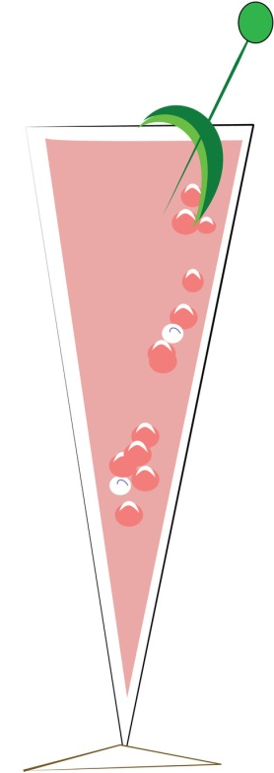
Eye Appeal
Eye appeal is very important. It impacts a guest's experience in our Restaurant in three ways:

It Is A Sales Tool
There is a certain "something" about a unique drink that arouses the guest's curiosity enough to ask the server about it. This is an excellent opportunity to use salesmanship to introduce guests to our unique products.

It Enhances the Flavor of a Cocktail
Eye appeal is an important part of a guest's impression of a mixed drink. If a drink is served in a sparkling, clean glass with fresh and attractive garnishes, it will seem to taste better than the exact same drink served in a spotted glass with an inferior garnish.

Serves As A Statement Of Our Overall Quality
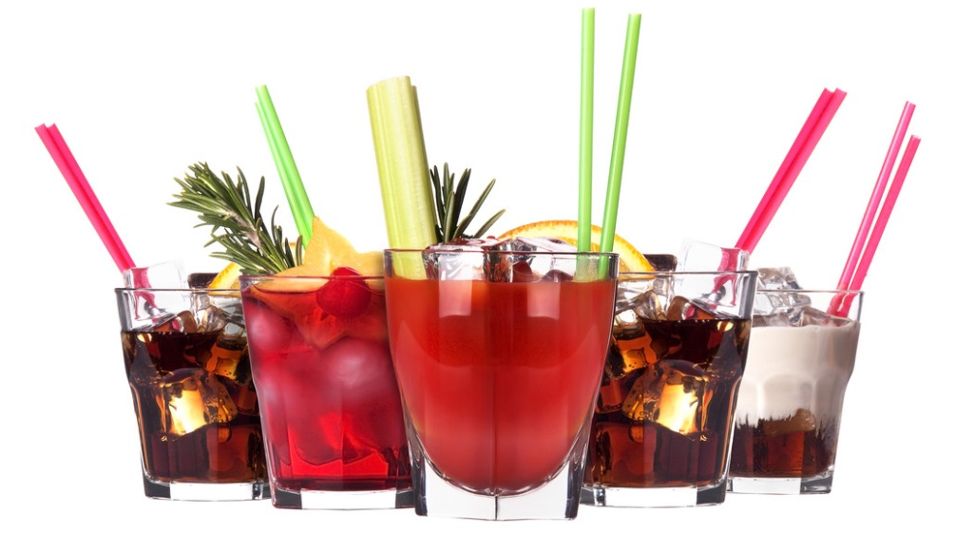
Every drink we serve is an example of the quality of our Restaurant. Inferior products or garnishes should never be used. There is no reason eye appeal cannot be 100% correct 100% of the time.

Garnishes
A good garnish increases the overall appeal of a drink. It should not detract from the drink or make it difficult to consume the drink.
A garnish should be vivid in color and fresh in appearance with no visible signs of age or deterioration.
A garnish is part of the recipe and is an essential part of the drink. The drink recipe book gives sensitivities, which must be observed for all garnishes.

Quality Hints

Cutting Fruit
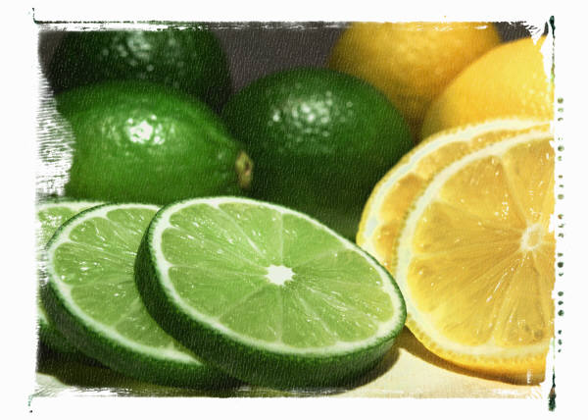
Always wash fruit in cold water before cutting.
Always use a clean cutting board.
Use a clean, sharp knife.

Stocking
Only stock enough fruit for any given 2-hour period (both at the point and service wells).

Storage
Always store garnishes refrigerated, covered, and labeled.
Do not store old garnishes on top of new garnishes.
When storing citrus garnishes, which have been stocked, rinse them with soda or water, and drain before coverage and refrigerating.
Cherries, olives, and cocktail onions should be stocked and stored in their own juice.
Cut celery should be stored in water to retain crispiness, and stocked on the station in ice water.

Waste/Quality Control
The most effective way to control garnish waste is to use accurate pars. Your manager will demonstrate where your pars are recorded and how to use them.
Quality control is everyone's responsibility. Garnish quality must be judged each time a garnish is stocked, stored, or used.

24-Hour Garnish Cycle
Using a 24-hour garnish cycle ensures garnish freshness. To begin this cycle, assume that when the bartender begins to cut garnishes, no fruit is left from the previous day.

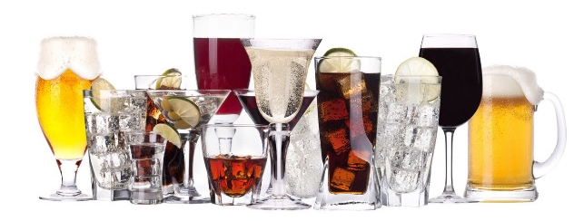

Bar Cleanliness
Cleanliness at the bar is essential. Our guests' impression of us is at stake. Even at hours of peak business, your bar should appear clean and attractive.
Your store will have a list of daily housekeeping duties for the bar. This list will include the following:
Stainless counters | Blenders
Sinks | Mixers
Ice bins | Back up liquor
Liquor bottles | Beer taps
Trash cans | Coffee burners
Bar surface | Beer drains
Refrigerators and Coolers | Speed rails
Plastic bottles | Storage areas
Glassware | Soda gun hoses and nozzles
Condiments and holders | Cash registers
These tasks are specifically assigned as A.M. or P.M. duties to the opening bartender, early out bartender, or closing bartenders/barback.
On a weekly basis, every part of the bar is thoroughly cleaned.

The weekly clean up will include:
Cleaning out all storage areas.
Cleaning out all par shelves.
Cleaning stainless counters and sinks.
Cleaning out walk-in and reach-ins thoroughly.
Cleaning soda gun - nozzles, holders, and hoses.

Bake Station Responsibilities
You are responsible for operating the bake station in tandem with the bar. The bar/bake station is designed to maximize the speed and efficiency of preparing and displaying all our baked goods, while producing the drinks ordered by our guests.

Raw material

Procurement:
While procuring and receiving the raw material, the food handler shall ensure that:
- All raw materials and food ingredients should be procured from approved suppliers.
- Records of raw materials & source of procurement shall be maintained in a register for inspection.
- All raw materials should be checked for visible deterioration and cleaned physically thoroughly.
- No raw material or ingredient thereof shall be accepted if it is known to contain parasites, undesirable micro-organisms, pesticides, veterinary drugs or toxic items or decomposed or extraneous substances, which would not be reduced to an acceptable level by normal sorting and/or processing.
- Raw materials should be purchased in quantities that correspond to storage/preservation capacity of the establishment.
- Packaged raw material must be checked for 'expiration date'/ 'best before'/ 'use by' date, packaging integrity and storage conditions.
- Receiving temperature of potentially high-risk food should be at or below 41 F.
- All material should be examined at point of receiving for Labeling, giving Product name, Manufacturers name and address, date of manufacturing and expiration. Material should be easily traceable to its source.

Storage:
- After receiving and accepting the raw material, there comes the need of storage. The storage facilities shall be designed and constructed to avoid cross-contamination during storage, permit adequate maintenance and cleaning and shall avoid pest access and accumulation. Cold Storage facility shall be provided for food that requires being stored below 41°C.
- Pallets to be cleaned at regular intervals to keep them free of cobweb, dust, dirt etc. and also to be inspected regular any repair/ replacement, if required.
- All wrapper rolls to be shrink-wrapped.

PREMIXING & MIXING, FERMENTATION, HANDLING OF BULK DOUGH

Premixing:
- Flour should be sieved through minimum 32u mesh and the sieve should be cleaned regularly.
- Sugar bags to be free from any external contamination like dust, dirt, rice bran, etc.
- Egg trays to should be free from dirt or pests.
- Broken egg-shells to be stored in plastic bags and disposed of at regular intervals.

Mixing:
- Mixing area should be clean & dry without any spillage.
- All mixing utensils should be free from grease and old batter.
- Mixing bowls, beaters and scrappers are to be washed regularly to prevent contamination.
- Egg whisk to be added in mixing through strainer only. The strainer to be cleaned with hot water at least once in each shift. The strainer is to be dipped in 500ppm Sodium Hypochlorite solution, when not in use.
Dividing and PREPARATION of individual units
- From bulk dough, unit dough piece or batter is separated for processing before baking.
- High speed machines, Semi-automatic equipment, and hand work are required.
- Food should be prepared at steady pace and not allowed to stand more than necessary for process.
- Temperature control should be maintained as needed by process.
- Dough bits, dusting flour, and oil if left on worktable for long, will go rancid and will allow bacterial and fungal growth.

BAKING& FINISHING
- Oven area should be segregated, to avoid cross contamination with fumes and smoke.
- Baking room should be clean & dry. This room is to be mopped at least once in each shift
- Controls should be maintained on temperatures, humidity, and timing of baking.
- Baked goods are free from microorganisms, but as they cool, they provide excellent medium for mold growth. Cooling should be done in as clean an environment as possible.
- Finishing, cutting, and decorating should be done with all precautions of good manufacturing practices, and personal hygiene.

Cooling
Proper cooling is essential after baking. The product should come to room temperature naturally before packaging. Improper cooling will lead to condensation in product after packaging and early spoilage due to microbial growth. Cooling should also be done in clean and cool air so as to avoid contamination of product.

PACKAGING
- Packaging is done as a medium to safeguard the food from external spoilage as well as means to provide product information to the consumer.
- Use of clean baskets and trays should be done to hold the finished product before packaging.
- Often a metal detector step should ideally be incorporated during packaging to rule out possible metal contamination.
- Only food grade packaging material (printed/unprinted) should be used for wrapping and packaging of food items. The food grade certificate/ declaration should be checked in the COA during receiving of the materials.
- All the products should be labeled properly.

STORAGE
- Product storage should be away and separate from Raw material storage to avoid cross contamination.
- Immediately after packaging and proper labeling, the products should be placed in the rooms provided for storage under required temperature and humidity conditions.
- Product Storage is temperature sensitive, can be classified into:
  - Ambient storage - for dry products like Khari, toast , bread, biscuit.
  - Cold storage - Chocolate and fresh cream cakes, pies, pastries
- Product should be stored on pallets and away from the wall and not the floor, near the wall.
- Temperature and relative humidity of the storage area should be maintained to optimum required level.
- FIFO system should be applied for dispatch of all products.

Slicing/Packing of Bread and Confectionary Products
- Cool baked products on clean racks and trays. Baked products should be covered during cooling.
- Clear crumbles that are left after slicing the products.
- Use clean packaging to pack the products.
- Slicer blades & conveyor belts to be sterilized at least 3 times in each shift or as/when required
- Contact parts of packing machines are to be cleaned and sterilized.

Retail and Display
- Ensure that products are stored in clean display cases.
- Ensure products are stored at appropriate temperatures (e.g. cakes with fresh cream should be stored in chiller display units at 41ºF or below).
- Do not display products with perishable fillings beyond 4 hours at room temperature. Adopt first-in first-serve approach in the display of products for sale.
- A time stamp is to be used for the products to inform consumers on the “consume-by” date.

Closing Out A Table

Presenting the Check
- Before presenting the check, look it over to make sure you have charged for everything correctly.
Drinks
Coffee
Desserts
- After you have determined that the check is correct: give the check to the host of the table (if known) or place it in the center of the table and say, "Thank you.” Make sure to let the customer know that you are the cashier and will take care of the check whenever they are ready.
- After presenting the check: take a few steps and glance back at the table. If they already have their cash or credit card ready, it may mean they are in a hurry to leave. If this is the case, try to close the transaction immediately or as soon as possible. Guests will notice and appreciate this.
We use a server banking system; you are your own cashier. You are responsible for all your money, including cash, credit card vouchers, comps and discounts until the end of your shift. You must start your shift with your own thirty-five dollars that is used to make your opening change bank. A sales station can only be opened or closed by a manager. NO EXCEPTIONS.
If the customer is paying cash, do not make change right at the table!! Take the check and cash to the back-of-house and make change. Return the check and change on either a tip tray, or a book, along with the receipt. If the customer is paying with a credit card, follow the house procedure. Once the guest has signed the voucher, pick up both the check and voucher, and again, thank the customer. DO NOT examine the tip as you leave the dining room!!
REMEMBER, the process of closing out the check is the time when the guest is deciding on the tip amount. A bad impression here can undo all previous good impressions and effect your gratuity.

The Farewell
When your guests are departing, we have four distinct objectives:
- To make sure their experience in our restaurant was pleasurable.
- Thank them, by name, for their patronage.
- To invite them back for another visit soon.
- To make sure their last impression is a positive one.

Methods of Payment
Approved methods of payment are cash, VISA, Master Card, and American Express.

Cash Handling procedure
Here are the procedures to follow when receiving a payment in cash:
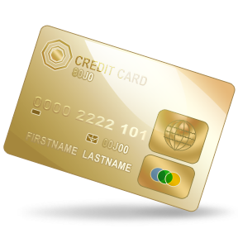
- Never make change at the table - go to the nearest server station and always count it twice.
- Give the guest some one’s and five-dollar bills that they can use to tip you.
- Return the change to the guest's table on a tip tray or book.
- Always keep your cash and receipts in a server wallet or your apron.
- Never leave your money or server wallet unattended.
- If you are concerned about carrying too much cash during a shift, make a drop with a manager in exchange for an IOU.
- Accurately cash out at the end of your shift with all monies due properly deposited in the cash drawer accurately balanced.

Card Handling Procedure

The Authorized Process
Use extreme care when applying a charge to a guest’s card. Accurately ring up all the guest transactions with the correct menu pricing and on the correct credit card.
Read your screen! Check, Check, Double Check!
Ask yourself, “Am I positive that I am charging he correct amount to the correct card?” Verify accuracy by double-checking the last 4 digits of the credit card number.
You may easily void credit card mistakes or an entire transaction if the tip has not yet been entered. This is your last chance to check and correct any mistakes!
The check is neither closed nor is the guest’s card charged until you have entered your tip.
Do not enter a (0) in the tip field unless you have received a zero tip and intend to close out a charge. Entering a 0 tip before printing a charge closes out that check; you will not be issued a charge voucher for the guest to sign.
Credit card handlers MUST:
- Never leave a guest’s card unattended.
- Obtain proper authorization for a credit card transaction. If you are unable to obtain authorization through the card swipe, you must either key in the card number.
- Accurately close out tip amounts to guest cards.
- Never alter the tip amount written by the guest.
- If you suspect a tip amount has been altered, you must show it to a manager immediately.
- Never use a guest’s card or card number for any purpose other than charging the guest’s purchase.
- Obtain the guest’s signature on the receipt.
If a guest makes an addition error when adding the tip to the check total, a manager must be advised of the discrepancy. The close out check should be initialed by the manager acknowledging they were of the addition error.

Opening & Closing Duties

Every shift at the restaurant has opening, running, and closing duties. These duties are extremely important in assuring smooth daily operations and ongoing quality service. These duties require teamwork, and through teamwork, we will maintain excellence in service.
Opening and closing duties will not be considered complete until approved by the manager on duty.
Running duties refer to ongoing duties while the Restaurant is open for business. The responsibility of making sure these duties are being done during the shift is that of you and your teammates.
Each station is assigned its own duties. Some duties will require individual effort, while others will require team effort.

End of Shift Responsibilities
At the end of your shift, you will be responsible for cleaning and restocking the bar and bake station.
If you work on A.M. shift or a P.M. early out, you will leave the station clean, organized, and stocked with liquor, beer, wine, mixes, garnishes, and glassware for the closing staff.

Cleaning responsibilities:
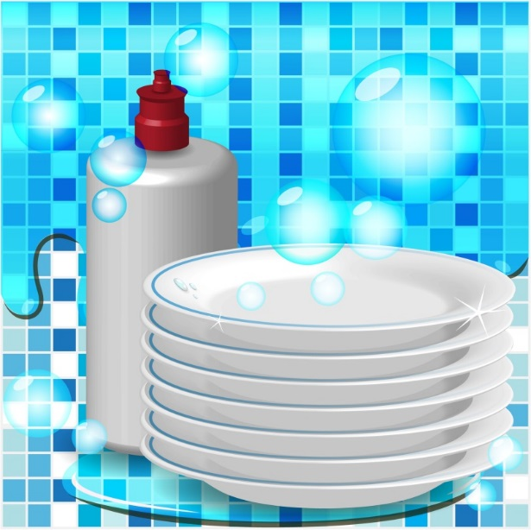
Fruit containers
Mixing glasses
Tins
Strainers and utensils
Baking pans and mixing bowls
Bar top
Ice bins
Stainless surfaces
Floor
Removing all bottles, cleaning the speed rail and the bottles, and reorganizing the bottles.
Flushing beer drains and cleaning drip pans and grills.
Emptying trash and storing trash cans.
Requisitioning liquor.
Completing walk through with the Manager.

Security Responsibilities
- When coming on duty, the Manager will supply you with the appropriate cash banks. You should count this prior to starting your shift.
- You are responsible for any differences when checking out.
- If you need change during your shift, notify your Manager.
- If you accumulate over $1,000 in cash in the register drawer, the Manager will remove the excess leaving only sufficient change reserve for you to operate.
- The Manager and you will verify and record (in the POS. as a Drop) the amount of cash taken. The cash will be dropped in the safe and will be witnessed by another Manager or staff member.
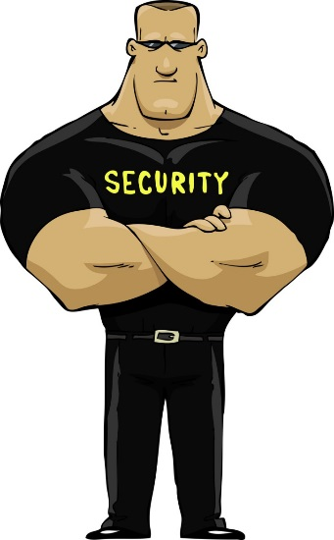
- Upon checking out your register, call the Manager for an escort to the office and lock the door.

Check-Out Procedures
At the end of your shift, you are required to do an accountability or checkout, which you turn into the manager.

Before you Start the Paperwork Process, You MUST:
- Complete your sidework, including salt, pepper and sugar caddies.
- Check out with the shift leader and have them sign the purple chit.
- Verify that all of your checks have been closed out to transferred. Do a Cashout Report including your closed checks. Do not clear your totals until you have balanced the physical paperwork.

Accountability process
- Sort all forms of payment into separate stacks.
- All paper forms of payment require an adding machine tape total for each individual stack. The tape should be stapled to the top of each stack and include your name, day, date, POS number, shift and station (if applicable).
- Staple all your credit card charges and gift card receipts together, keeping the final receipt slip and the copy with guest’s signature together. (If you have any zero balance gift cards, clip the corner and turn them in as well.)
- If you have credit card and gift card charges, run two tape totals to verify your credit card and gift card charges against Credit Card Total stated on the Cashout Report
  - Tape of the base amount plus tips [Ex. (24 + 4) + (30 + 6) + (100 + 15) = 179]
  - Tape if the final amounts added together [Ex. 28 + 36 + 115 = 179]
If the totals for the two stacks do not match:
There is a mistake somewhere and you must find and correct it before you go on.
Start to look for the mistake by re-reading the tapes or check the addition on the charge slips. If there is a mistake in the guest’s addition, you must see a manager. Only a manager may adjust or correct the total on a charge.
If you have lost a charge voucher and cannot find it, you must see a manager.

Accountability process
- If you have one or more adjustments, run a tape total. Each quality issue adjustment must have a manager signature on it. Quality issue adjustments are a payment method and when missing are considered to be shortages.

Gift Certificates
- If you redeemed one or more gift certificates: run a tape total to verify your gift certificates redeemed.
- Note: When gift certificates are redeemed in conjunction with a credit card payment, attach a second copy of the credit card voucher to the gift certificate. Do not mix gift certificate in with credit card vouchers.

Cash
- Count and verify your cash against the Cash to Remit on the Cashout Report.

Zeroing Totals
After you have balanced your physical paperwork totals against your first printout of your Cashout Report, print a second report. This time you will touch YES when prompted to clear your totals for the shift. No need to include your closed checks on your zeroed Cashout. (Staff you have a negatice cash accountability need to rin a 2nd *not zeroed* copy of the Cashout Report before cleaing totals and receiving a 3rd copy of the report. You will turn-in one copy to the cashiet to receive the balance of your tips owed.

Time out
Be Certain to “Time Out” in the POS system after every shift.
- Select Timeclock
- Swipe card
- Select punch out
- Declare tips and tear off receipt

Tip Declarations
- When you clock out, you will be prompted to declare your total top amount. (This amount is the total tip amount, which must include charged and cash tips retained after tip out.)
- After you enter in the total tip amount, the system will automatically deduct any charged tips and calculate the cash tips amount accordingly. You will have the opportunity to confirm your total tip amount when you touch the “Punch Out” button.
- Once you have confirmed your tip amount, your timecard will print out and will include a breakdown of your declared tips. Save this report for your records.

Performance Standards
- We do not have "to-go cups" under any circumstances. No one may take any bottle or glass outside of the building.

- We do not keep purses or any personal belongings for the customers. This includes employees when they are in on their off nights.
- Advise a Manager of any customer who appears to be intoxicated.
- IF YOU ASK TO LEAVE...YOU CLOSE.
- If you fail to show up for a shift, you will meet with the General Manager prior to your next scheduled shift.
- Notify a Manager of anything out of the ordinary, or any possible problem.
- A smile and friendly attitude are part of everyone's uniform and will increase your income.
- All employees are required to have a telephone number where they can be reached.
- If you notice anything in the Restaurant that is broken or damaged, notify a Manager.
- Do not leave the bar on break without checking with a Manager.
- Do not eat, drink, or smoke while on the floor.
- You must be in the bar working in completed uniform at your scheduled time.
- A Manager must approve all schedule changes.
- If you wish to continue to have a break area, keep it clean. Do not leave glasses, ashtrays, napkins, etc., lying out.
- You must clock in and out as scheduled. BE ON TIME
- Print a copy of your schedule each week. Do not call up to the Restaurant to find out your schedule. You are responsible for knowing your schedule.
- You may not receive personal phone calls at the Restaurant, except in a real emergency. Please inform your friends and family.
- Schedule requests are due one week prior to the posting of the schedule. Leave them in the designated area.
- You may not come into the back of the house after you have been drinking. You may not take drinks into the break room.
- If you want to return to the Restaurant after work and have a cocktail, maintain a very high standard of behavior, leave at last call, and be the very first to leave when the lights go up.
- If you have a suggestion on how to make the Restaurant run more efficiently, please give them to a Manager.

- Remember to enjoy yourselves and have fun while you are here. Let the Managers handle all problems, big or small.
- You will greet your guests with -
A smile
Your name
A welcome
Promotional information and specials
- When your guests leave, you will thank them for coming and invite them back.
- You will clean stations during your shift - EVERYTHING from floor to ceiling.
- Your service well is your station -- KEEP IT CLEAN!
- Teamwork is ESSENTIAL.
- Do not grab glasses from people's hands at last call. Find a Manager, and let them assist.

You Should Not
- Make unnecessary noise. This is annoying to guests dining nearby.
- Overfill a glass with mix; it weakens the drink.
- Be overly familiar with a guest when he/she is with others.
- Do not water down drinks or short pour drinks. Do not try to correct the situation by refusing or discontinuing service to a guest. This could jeopardize your relationship with other guests.
- Our intent is to provide our guests with an enjoyable experience in our Restaurant and to ensure that they leave our Restaurant safely.
- Our alcohol awareness written material informs employees about recognizing the signs of intoxication. Employees are shown how to prevent intoxication and what procedures to follow if a guest becomes intoxicated.

Doubles
Our pricing on doubles is as follows: for a double drink, charge twice the normal price. There are two reasons for this policy:
We do not want to encourage our guests to become intoxicated.
In mixed and blended drinks, adding an extra shot of liquor alters the flavor. We believe that the standard recipes are the best way to serve these drinks.
If a guest requests a double mixed drink, explain the price and advise him that we do not recommend serving the drink that way. If they persist, accommodate them, and then notify a Manager.

Conclusion
There is a lot of information contained in this manual! Believe it or not, however, there is even more information that is not.
We have given you the basics, as we view them, and how we would like them to be conducted.
We want you to use the service tips in the manual, along with your common sense, and above all, YOUR individuality, to help create an atmosphere that will encourage good times for our customers, and yourself. If this happens, you will be ensuring the success of not only the restaurant, but also yourself.
GOOD LUCK!!!

