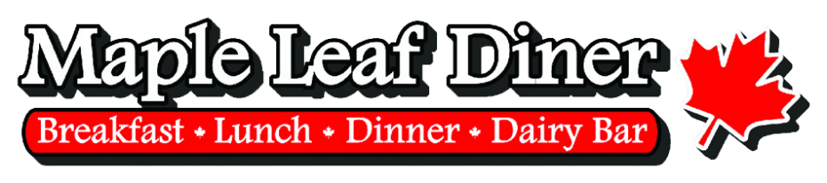



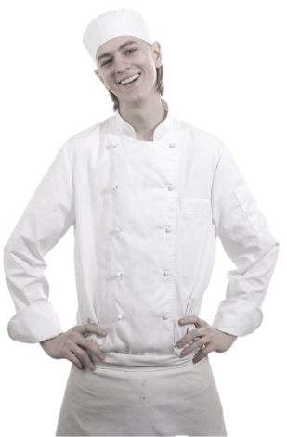

Employee
Handbook

2019

Employment Policies and Procedures
Employment
Policies & Standards

Welcome Letter
Welcome to the Eh-Team!
We look forward to the opportunity to work with you and want you to know that we recognize our employees as our most valuable resource. Our continued success in providing the world’s most enjoyable restaurant experience to our customers depends on quality people like yourself and your fellow employees. We want you to enjoy your time here and are committed to helping you succeed in your new job.
We have prepared this handbook to answer some of the questions that you may have concerning MLD and its policies. This handbook is intended solely as a guide. Read it thoroughly. If you have questions about anything, contact your trainers or managers for assistance.
We hope you find your time with us to be an enjoyable and rewarding experience.

Sincerely,
The Maple Leaf Management Team

Table of Contents
Welcome Letter
Our Mission
Our Culture
About this Handbook
Employment Policies
Standards of Conduct
Harassment
- Definition of Harassment
- Sexual Harassment
- Reporting Harassment is Everyone's Responsibility
- Procedures for Reporting Harassment Claims
- Investigation of Claims
- Retaliation is Prohibited
Absences
- Tardiness
- Resignations
Payment Procedures
- Tip Reporting
- Time Clock Procedures
- Employment Status
- Payroll Checks
- Payroll Deductions
- Change of Address
- Lost Paychecks

Benefits
- Health Insurance
- Family and Medical Leave
- Holidays
- Vacations
- Worker’s Compensation
- Employee Meals
Employee Use of Social Media Websites
Restaurant Policies & Practices
- Customer Service
- Management / Employee Relations
- Performance Appraisals
Safety & Sanitation
- Fire Safety
- Fire Emergency Procedure
- Preventing Fires
- Floor Safety
- Major Cause of Food Borne Illness
- Always Wash Your Hands After You
- Dispose of Waste Properly
- Keep Insects and Animals Out
- Handle Ice and Tableware Properly
- Avoid Cross Contamination
- Store Foods and Equipment Properly
- When cleaning stationary equipment
- Preventing Falls
- Preventing Electric Shock
- Lift Properly
- Moving a Cart Properly
- Preventing Cuts
- Preventing Burns
- Safe Chemical Handling
- Reading the MSDS (Material Safety Data Sheets)
Dress Code
- Dining Room Dress Code
- Kitchen Dress Code
Accidents and Emergency Situations
- Crime and Robbery
- Fire Protection
Alcohol Serving Policy
LOST AND FOUND
Proprietary & Confidential Information
- Solicitation
Cellular Phone Use Policy
- Cell Phone Use for Business While Driving is Prohibited
- Cell Phones in the Restaurant - Management
- Cell Phones in the Restaurant - Staff
- Emergency Use of Cell Phones – Staff
- Violation of Policy is Cause for Disciplinary Action
Policy Regarding Supplier Gifts and Kickbacks
- INTRODUCTION
- DEFINITION
- RELATIONSHIPS WITH VENDORS/SUPPLIERS
- KICKBACKS FROM VENDORS/SUPPLIERS
- GIFTS AND GRATUITIES
Handbook Receipt

Our Mission

The Maple Leaf Diner mission is to enrich the lives of our guests, our employees and owners. We do this through superior quality food and beverages, legendary customer service, sales growth, cost controls and treating our employees like family. We believe that our employees are our most important resource and our success depends upon creating and retaining a staff capable of delivering an exceptional dining experience to every customer, every time.

Our Culture

Maple Leaf’s success depends on our people. Our restaurant can only prosper and provide opportunities for employment and growth when we continually improve ourselves, and the work we do. We recognize however, that success is not measured by sales; guest counts, and numbers alone. We are measured as much by the way in which we achieve our goals, as we are by the actual achievements themselves. We believe that a commitment to uncompromising values and integrity should always guide our decisions and actions as we pursue our goals. Following are the core values that form the foundation of our measurement of success:

We believe in providing LEGENDARY SERVICE. Our goal is to provide the kind of unique and genuine sort of personal care and attention that our customers tell stories about. We like to say that “Disney is no longer the happiest place on Earth”.

Constant Improvement. We believe that “good enough” isn’t. We never stop trying to do it better, no matter how good we are. We constantly strive to "raise the bar.”

We believe in the ongoing training and development of our people. We see it as a worthy investment in the future of the restaurant and as a way of enabling our people to achieve their potential in whatever they do.

We believe in honesty and trust. We work to build trust with others in each and every transaction and interaction. We recognize that honesty and trust form the bond that holds organizations and relationships together.

We believe our continued success depends on teamwork. We know that great achievements are only possible from helping and respecting each other.


We believe in doing business in a professional and orderly manner. We take great pride in having good systems, standardized procedures and being organized.

We believe in being responsible to others and to ourselves. We do what we say we are going to do when we say we are going to do it. We believe in personal accountability and avoid blaming others when things don’t turn out as planned.

About this Handbook
This handbook is designed to help you get familiarized with the Maple Leaf Diner. We want you to understand how we do business and how important you and every employee is in helping us take care of our guests and making this a fun and rewarding place to work.
The policies stated in this handbook may change from time to time. It isn’t flawless either. We’ve done our best to include as much information as possible in an easy-to-understand manner.
This handbook is not a contract, which guarantees your employment for any specific time. Either you or MLD may terminate your employment at any time, for any reason, with or without cause or notice. Understand that no supervisor, manager, or representative of MLD, other than the owner of MLD has the authority to enter into any agreement with you for employment for any specified period or to make any such promises or commitments.
We wish you the best of luck in your position and hope that your employment with MLD will be a very enjoyable and rewarding experience.

Employment Policies

General Policies
- We are a NON-smoking business.
- Employees are not to eat and chew gum while working.
- Employees are not allowed to go in and out of the back door, employees must enter and exit from the main restaurant entrance.
- We are not responsible for any personal items brought onto the premises.

Hiring
It’s our policy to hire only United States citizens and aliens who are authorized to work in this country. As required by law, employees will be required to provide original documents that establish this authorization within three days of their date of hire. If the documents are not provided within the three-day period, we have no choice, under the law, but to terminate the employee until the appropriate documents are provided. Employees and employers are both required to complete a form furnished by the Department of Labor, form I-9. In Section 1 of form I-9, the information provided by the employee must be valid and authentic. If at any time during an employee’s employment, it is discovered that any document used was invalid or not authentic, the employee must, by law, be immediately terminated.

Non-Discrimination
MLD is an equal opportunity employer. We will not tolerate discrimination based on race, sex, age, national origin, religion, sexual orientation, or disability. Employment decisions, such as hiring, promotion, compensation, training and discipline will be made only for legitimate business reasons based upon qualifications and other nondiscriminatory factors.

Age Requirements
All servers and bartenders, as per the law, must be at least 18 years of age. Employees under the age of 18 must comply with all federal wage and hour guidelines, no exceptions. The required work permits much be supplied when applicable. No employees under the age of 18 years can take orders for or serve alcoholic beverages.

Orientation Period
You have been through our employee selection process, have been selected for employment and appear to have the potential to develop into a successful employee. However, we want the opportunity to begin the training period, get to know you, see how you fit in with your co-workers and determine if you are willing and able to carry out the responsibilities for the position in which you were hired.
It’s also important for you to get to know us and become familiar with how we operate to find out if this job is the right fit. We, therefore, have a 30 day Orientation Period for that purpose referred to above. The 30 day period allows both you and the Company to see whether or not it’s a good fit and if not, part company as friends.
During the Orientation Period you will begin your training and be observed by management. Also, during this time if you feel you do not understand what’s expected of you or that you need additional training, we encourage you to ask questions and seek additional help from our management staff.

Training
To help you be successful in your job you will receive adequate training. You will not be expected to be on your own until you are ready. You will participate in detailed training programs and receive training materials to help you perform your job the right way. Your trainers are considered our “best” and have been certified to train for that position.
We spend considerable time and money educating our trainers to prepare each new employee for their job. We want you to be a knowledgeable and productive member of our staff.

Schedules
Schedules are prepared to meet the work demands of the restaurant. As the work demands change, management reserves the right to adjust working hours and shifts. Schedules are posted weekly (day of week / time). Each employee is responsible for working their shifts.
We suggest that you arrive 10 to 15 minutes before your shift begins so that you have time to get settled and ready for your shift. You should arrive for your shift with enough time to make sure you’re ready to work when your shift begins. You may clock in no earlier than 5 mins before your shift begins. Once you clock in, you are expected to be ready to start work immediately.
Schedule changes may be allowed only if you find a replacement and get a manager’s approval. To be valid. The restaurant usually requires high levels of staff on or around holidays, sporting and other special events.
Please remember that even though we will try to comply with your requests, there is no assurance that you will get the requested time off.

Overtime
In accordance with Federal Minimum Wage Law, employees are paid overtime when they work more than 40 hours in one week. Hourly employees are paid at one and one-half times their basic straight time rate for all overtime hours worked. Tip credit will be factored into the hourly rate for tipped employees.

Standards of Conduct
Consistent with our Mission and values, it is important for all employees to be fully aware of the rules, which govern our conduct and behavior. In order to work together as a team and maintain an orderly, productive and positive working environment, everyone must conform to standards of reasonable conduct and policies of the Restaurant. AN EMPLOYEE INVOLVED IN ANY OF THE FOLLOWING CONDUCT MAY RESULT IN DISCIPLINARY ACTION UP TO AND INCLUDING IMMEDIATE TERMINATION WITHOUT A WRITTEN WARNING.
- Invalid Work Authorization (I-9 form)
- Supplying false or misleading information to the Restaurant, including information at the time of application for employment, leave of absence or sick pay.
- Not showing up for a shift without notifying the Manager on duty. (No call, no show, no job)

- Clocking another employee “in” or “out” on the Restaurant timekeeping system or having another employee clock you either “in” or “out.”
- Leaving your job before the scheduled time without the permission of the Manager on duty.
- Arrest or conviction of a felony offense.
- Use of foul or abusive language.
- Disorderly or indecent conduct.
- Gambling on Restaurant property.
- Theft of customer, employee or Restaurant property including items found on Restaurant premises.
- Theft, dishonesty or mishandling of Restaurant funds. Failure to follow cash, guest check or credit card processing procedures.
- Refusal to follow instructions.
- Engaging in harassment of any kind toward another employee or customer.
- Failure to consistently perform job responsibilities in a satisfactory manner within the 30 day orientation period.
- Use, distribution or possession of illegal drugs on Restaurant property or being under the influence of these substances when reporting to work or during work hours.
- Waste or destruction of Restaurant property.
- Actions or threats of violence or abusive language directed toward a customer or another staff member.
- Excessive tardiness.
- Habitual failure to punch in or out.
- Disclosing confidential information including policies, procedures, recipes, manuals or any propriety information to anyone outside the Restaurant.

- Rude or improper behavior with customers including the discussion of tips.
- Smoking or eating in unapproved areas or during unauthorized breaks.
- Not parking in employee designated parking area.
- Not entering and exiting the restaurant through approved entrance.
- Failure to comply with Restaurant’s personal cleanliness and grooming standards.
- Failure to comply with Restaurant’s uniform and dress requirements.
- Unauthorized operation, repair or attempt to repair machines, tools or equipment.
- Failure to report safety hazards, equipment defects, accidents or injuries immediately to management.

Drug and Alcohol Policy
MLD is committed to providing a safe and productive work environment for its employees and patrons. Alcohol and drug abuse pose a threat to the health and safety of fellow employees, patrons and to the security of our equipment and facilities. For these reasons, MLD is committed to the elimination of drug and/or alcohol use and abuse in the workplace.
This policy outlines the practice and procedure designed to correct instances of identified alcohol and/or drug use in the workplace. For the purpose of this policy and its enforcement, ‘drugs’ are classified as any drug that’s illegal under federal, state or local law and / or any drug that is illegal under the federal Controlled Substances Act. This policy applies to all employees and all applicants for employment of MLD.

Drug-Free and ALCOHOL-FREE Workplace
Employees should report to work fit for duty and free of any adverse effects of illegal drugs or alcohol. This policy does not prohibit employees from the lawful use and possession of prescribed medications. Employees must, however, consult with their doctors about the medications’ effect on their fitness for duty and ability to work safely and promptly disclose any work restrictions to their supervisor. Employees should not, however, disclose underlying medical conditions unless directed to do so.


Work Rules
The following work rules apply to all employees:
- Illegal drugs are defined in this policy to include: cocaine, ecstasy, hallucinogens, amphetamines, steroids, heroine, PCP, marijuana and other substances that are illegal in the State of Florida.
- Whenever employees are working, are operating any company vehicle, are present on company premises, or are conducting related work off-site, they are prohibited from:
  - Using, possessing, buying, selling, manufacturing or dispensing an illegal drug (to include possession of drug paraphernalia).
  - Being under the influence of alcohol or an illegal drug as defined in this policy.
- The presence of any detectable amount of any illegal drug or illegal controlled substance in an employee’s body while performing company business or while in a company facility is prohibited.
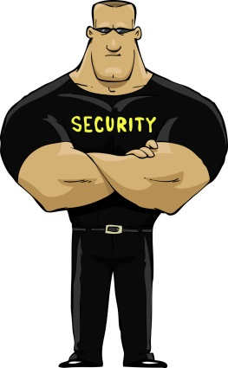
- MLD will not allow any employee to perform their duties while taking prescribed drugs that are adversely affecting the employee’s ability to safely and effectively perform their job duties. Employees taking a prescribed medication must carry it in the container labeled by a licensed pharmacist or be prepared to produce it if asked.
- Any illegal drugs or drug paraphernalia will be turned over to an appropriate law enforcement agency and may result in criminal prosecution.

Inspections
MLD reserves the right to inspect all portions of its premises for drugs, alcohol or other contraband. All employees and visitors may be asked to cooperate in inspections of their persons, work areas and property that might conceal a drug, alcohol or other contraband. Employees who possess such contraband or refuse to cooperate in such inspections are subject to appropriate discipline up to and including discharge.

Crimes Involving Drugs
MLD prohibits all employees from manufacturing, distributing, dispensing, possessing or using an illegal drug in or on company premises or while conducting company business. Employees are also prohibited from misusing legally prescribed or over-the-counter (OTC) drugs. Law enforcement personnel shall be notified, as appropriate, when criminal activity is suspected.
Manager’s Signature |  | Date |  | Employee’s Signature |  | Date

Harassment

MLD is committed to providing a work environment that is free from all forms of discrimination and conduct that can be considered harassing, abusive, coercive, or disruptive, including sexual and other types of harassment. Actions, words, jokes, or comments based on an individual’s sex, race, color, national origin, age, religion, disability, pregnancy, sexual orientation, gender identity, gender expression, veteran status, military duty, genetic information, or any other legally protected characteristic will not be tolerated.
All employees, including hourly employees, members of management, and executives, are prohibited from engaging in harassment of any type. The Company will also take appropriate steps to ensure that its employees are not subjected to harassment by guests, vendors, and members of the public. Harassment will not be tolerated and will result in disciplinary action, up to and including immediate termination of employment. Non-employee violators of this policy are subject to expulsion from company facilities.

dEFINITION OF hARASSMENT

Harassment based on a legally protected characteristic is unlawful discrimination and is illegal under federal law and many state and local laws. Harassment is a pattern of physical and/or verbal conduct that a reasonable employee would find intimidating, undesirable, or offensive and has the purpose or effect of interfering with an employee’s work performance or creates an intimidating, hostile, or offensive work environment. All harassment is prohibited regardless of whether it takes place on the premises or outside, including at social events, business trips, training sessions or other company sponsored events. The types of conduct that are prohibited by this policy and that may constitute harassment include but are not limited to the following:

- Verbal conduct such as epithets, derogatory comments, foul or obscene language, jokes, nicknames (e.g., honey, old man, or boy), slurs, taunts, threats.
- Visual conduct such as derogatory or otherwise offensive posters, cards, calendars, photographs, cartoons, graffiti, drawings, or gestures.
- Physical conduct such as assault, unwelcome touching, blocking normal movement, or interfering with work

Sexual Harassment
Sexual harassment includes unwelcome sexual advances, requests for sexual favors and other verbal or physical conduct of a sexual nature, when:
- Submission to such conduct is made either explicitly or implicitly a term or condition of an individual’s employment or;
- Submission to or rejection of such conduct by an individual is used as the basis for employment decisions affecting such individuals, or;
- Such conduct has the purpose or effect or unreasonably interfering with an individual’s work performance or creating an intimidating, hostile or offensive work environment.
Sexual harassment may include individuals of the same or different genders. Specific examples of Sexual Harassment include
- Unwelcome sexual advances or propositions, requests for sexual favors, flirtation, sexually-suggestive gestures, whistling, or leering.
- Unwanted physical contact, including patting, pinching, kissing, grabbing, hugging, brushing up against another person, or inappropriate touching.
- Physical violence, including sexual assault.
- Sexual jokes, teasing, sexually suggestive noises, comments about appearance or an employee’s personal life, or sexual comments or stories.
- Display of sexually explicit or offensive materials in the workplace, including on a computer, smartphone, by email, or text message.

Reporting Harassment is Everyone’s Responsibility
MLD can only remedy harassment which you bring to our attention. To give the Company the opportunity to address and prevent future occurrences of harassment, it is everyone’s responsibility to immediately report any conduct that they believe may violate this policy, whether they were a victim of the conduct or were only a witness to it. Regardless of whether you are certain that another person’s behavior really constitutes “harassment,” it is your responsibility to report the behavior as soon as possible. Rarely, if ever, should you wait longer than the next regular business day before reporting conduct that violates this policy.

Procedures for Reporting Harassment Claims

Employees should immediately report the conduct to the manager on duty at the restaurant. If the manager on duty does not timely respond, or if the employee believes it would be inappropriate to report the conduct to that person, the employee should immediately contact the General Manager. If the General Manger does not timely respond or it would be inappropriate to report the conduct to the General Manager, the employee should immediately contact the General Manager’s supervisor or an owner of the Company (Adam Imburgia, adam@mldiner.com).

The availability of these complaint procedures does not preclude individuals who believe they are being subjected to harassing conduct from also promptly advising the offender that his or her behavior is unwelcome and requesting that it be discontinued. Any employee can raise concerns and make reports without fear of reprisal or retaliation.
Investigation of Claims

Your concerns will be investigated promptly, and appropriate remedial action will be taken in the event that it is determined that violations of the policy have occurred. All complaints will be kept in the strictest confidence possible, except as necessary to complete an investigation.
Depending on the nature and circumstance of the harassment, discipline can include, but is not limited to, counseling, suspension without pay, and/or termination of employment. Disciplinary action may also be taken against members of management who know of the behavior occurring, or of a complaint, and who fail to take immediate and appropriate action.
False accusations of harassment can have serious effects on other employees and the culture of the Company. If, after the investigation, it is clear that a complaining employee or a witness who participated in the investigation has maliciously or recklessly made a false accusation, they will be subject to discipline, up to and including termination of employment.
Retaliation is prohibited

Any employee who, in good faith, brings a harassment complaint, appears as a witness or assists in an investigation of such a complaint, serves as the investigator of the complaint, or is associated with another employee who made a complaint or participated in the investigation will not be adversely affected in terms of employment or retaliated against or discharged because of the complaint. Complaints of retaliation should be reported immediately using the same complaint procedure set forth above and will be promptly investigated according to the investigation procedures outlined above. Retaliation or threats of retaliation will be grounds for disciplinary action as set forth above, up to and including termination of employment.

Absences
All employees are expected to work on a regular, consistent basis and complete their regularly scheduled hours per week. Excessive absenteeism may result in disciplinary action, up to and including termination. Disciplinary action taken because of absenteeism will be considered on an individual basis, following a review of the employee’s absentee and overall work record.
- If you are going to be late or miss work, employees are expected to call and talk to (immediate supervisor, a manager, GM, owner) at least 2 hours before they are scheduled to work.
- Any employee who does not call or report to work for two consecutive shifts will be considered to have voluntarily resigned employment at MLD.
- Prior to taking a leave of absence for purposes of vacation, personal leave, military or jury duty, or other planned absence, an Employee Leave Request Form (available from your Manager or Supervisor) should be submitted to and approved by a manager, GM or owner.
- Employee Leave Requests should be submitted at least two weeks prior to the scheduled leave date, unless the request is due to an unexpected emergency. The nature of the emergency should then be shared with a manager, GM or owner.
- To return to work from an accident or medical leave, all employees must present a doctor’s release.
- Any employee who fails to return to work at the expiration of a personal leave of absence will be deemed to have abandoned their job, unless MLD is notified of a reason, satisfactory to management, for not returning to work at the end of the leave of absence.

Tardiness
Always arrive at the Restaurant 10 to 15 minutes before your shift. Employees must be prepared to start work promptly at the beginning of the shift. Your scheduled time is the time you are expected to be on your job, not arrive at the Restaurant. Repeated tardiness is grounds for termination. If it is not possible for you to begin work at your scheduled time, call the Restaurant and speak to the Manager on duty.

Resignations
You are requested to give a two-week notice of your plans to leave the restaurant. A notice is important so that we have time to hire someone to take your place. Giving a two-week notice is a professional courtesy and assures that you are eligible for re-hire and will not have a “left without resignation notice” on your employment record.

Payment Procedures

Time Clock Procedures
You should arrive at the restaurant 10 to 15 minutes before you are scheduled to start work. Notify the Manager on duty that you have arrived for your shift. You may clock in within 5 minutes of the start of your shift. All hourly employees are given an employee ID number to clock in and out on the Restaurant’s timekeeping system.
Tampering, altering, or falsifying time records or recording time on another employee’s ID number is not allowed and may result in disciplinary action, up to and including termination.

Employment status
Full-time Regular – Those hourly or salaried employees who have completed the thirty-day introductory period and are normally scheduled at least forty (40) hours per week.
Part-time Regular – Those hourly or salaried employees who have compleed the thirty-day introductory period and are normally scheduled for thirty (30) hours or less.
Full-time/Part-time Regular – Those hourly or salaried employees who have compleed the thirty-day introductory period and are normally scheduled for over thirty (30) hours and under forty (40) hours.

Tip Reporting
As an employee of a Restaurant, all the tips you receive, whether in cash or included in a credit card transaction, is taxable income to you. You are required, by federal law, to report and record your actual tips for each shift.
At the end of each shift, tipped employees must disclose on the Server Check-Out form, the amount of credit card tips and total tips less any tips shared with any other employees. Your tips will be recorded and reflected in total on your paycheck stub. Endorsement of your paycheck indicates that you acknowledge that your tip information on the stub is accurate and correct.
It is the employee’s responsibility to comply with IRS requirements of reporting all your tip income. While you are responsible for reporting all of your tip income, the Restaurant may be required to allocate additional tip income to any tipped employee that does not declare at least 8% of their gross sales as tip income.
We strongly encourage you to accurately report your tip income. This will reduce the chances of you being audited by the IRS and allows you to qualify for greater social security, unemployment and worker’s compensation benefits.

Payroll Checks
Paychecks are available at the Restaurant every other (your pay day) between the hours of (insert your time). After payday, you may pick up your paycheck during the same hours. Please understand that it may be difficult for anyone to be available to obtain your paycheck during peak business hours.

Payroll Deductions
Your paycheck will indicate your gross earnings as well as deductions for federal and state withholding taxes and social security and Medicare taxes. Federal and state withholding taxes are authorized by you based on the information you furnished to us on form W-4. If you want an explanation of your deductions or if you wish to change them in any way please see (manager, owner, administrative assistant).

As per state law, the Restaurant complies with court orders in connection to garnishments from employee paychecks as directed by the proper authorities. You will be notified of any court-ordered payroll deductions.

Change of Address
We ask that you report any address changes to (manager, owner, administrative assistant) as soon as possible so your year-end statement of income and deductions, form W-2, will be mailed to the correct address.

Lost Paychecks
Report lost paychecks to (manager, owner, administrative assistant). We will stop payment on the lost check and reissue you another check on the next payroll cycle. The reissued check will incur a deduction equal to the bank stop payment charge.

Benefits

Health Insurance
MLD offers health insurance coverage options through a Health Maintenance Organization (HMO). After you have completed your orientation period, we will pay (your $ amount) a month toward part-time employees’ insurance and (your $ amount) a month toward full-time employees’ insurance.


Family and Medical Leave
An employee who has been employed for at least 12 months and for at least 1,250 hours of service during the previous 12 months, may be granted unpaid leave for one or more of the following reasons:
- Birth of son/daughter and in order to care for such son/daughter.
- Placement of son/daughter with the employee for adoption or foster care.
- To care for a spouse, son, daughter or parent who has a serious health condition.
- A serious health condition that renders the employee incapable of performing the functions of his/her position.
A total of 12 workweeks of leave during any 12-month period may be granted under this policy. Such leave must be taken on a sustained or uninterrupted basis, except that intermittent leave may be taken for serious health care of the employee, child, spouse or parent. You must provide as much prior notice as reasonably possible.

Holidays
Due to the nature of the restaurant business you may be required to work holidays. It is currently our policy to be CLOSED on Thanksgiving Day and Christmas Day

Vacations
Vacations are provided by the Restaurant to enable employees to leave their work environment for a period of time and must be taken within the year in which they are earned.
All full-time employees who have been with the Restaurant for a consecutive 12 month period is eligible for a one week, paid vacation. Employees are considered full-time if they averaged over 30 hours of work per week the previous year.
Request forms (Employee Leave Request) for vacation are available from the (manager, owner, administrative assistant) and are to be submitted to the employee’s immediate supervisor and approved prior to granting vacation leave. Employees are asked to submit requests for vacation at least one month prior to the scheduled vacation date, unless the request is due to an unexpected situation. Efforts will be made to grant vacation time as requested, but business needs may require an employee to adjust his or her vacation time.

Worker’s Compensation
Worker’s compensation provides benefits for employees who suffer personal injury from accidents or illnesses arising out of, and in the course of, their employment with the Restaurant. An employee who is injured on the job, regardless of the severity of the injury or illness, should:
- Report the occurrence to the manager on duty.
- The manager on duty will need to obtain information as to exactly what happened, how the injury or illness occurred, the exact time and location, as well as any witnesses to the occurrence.
If an employee experiences a disabling work injury, the nature of which necessitates an absence from work, the (general manager, owner, administrative assistant), will provide the employee with information concerning his or her lawful benefits.

Employee Meals
Kitchen employees must take a 30 minute lunch or dinner break, shifts will be scheduled to be 8.5 hours long to allow employees a 30 minute break.
- We offer employee discounts. Discounts are ONLY for our employees and their purchases.
- Kitchen employees will receive one free Employee Meal per shift. Meal will be designated by chef daily. Meal will be chef’s choice.
- Iced Tea, Lemonade and coffee will be available to staff free of charge.
- 12oz Soda may be purchased for $0.50.
- 20oz Soda may be purchased for $1.00.
- 15% discount for employees dine-in or take-out.
- No desserts, milkshakes, floats or alcohol will be discounted.

Employee Use of Social Media Websites








While MLD encourages its employees to enjoy and make good use of their off‐duty time, certain activities on the part of employees may become a problem if they have the effect of impairing the work of any employee; harassing, demeaning, or creating a hostile working environment for any employee; disrupting the smooth and orderly flow of work within the company; directly or indirectly disclosing confidential or proprietary information; or harming the goodwill and reputation of MLD among its customers or in the community at large. In the area of social media (print, broadcast, digital, and online), employees may use such media in any way they choose as long as such use does not produce the adverse consequences noted above. For this reason, MLD reminds its employees that the following guidelines apply in their use of social media, both on and off duty:
- If an employee publishes any personal information about themselves, another employee of MLD, a client, or a customer in any public medium (print, broadcast, digital, or online) that:
  - has the potential or effect of involving the employee, their co‐workers, or MLD in any kind of dispute or conflict with other employees or third parties;
  - interferes with the work of any employee;
  - creates a harassing, demeaning, or hostile working environment for any employee;
  - disrupts the smooth and orderly flow of work within the office, or the delivery of services to the company’s clients or customers;
  - harms the goodwill and reputation of MLD among its customers or in the community at large;
  - tends to place in doubt the reliability, trustworthiness, or sound judgment of the person who is the subject of the information; or
  - reveals proprietary information or MLD trade secrets;
- the employee(s) responsible for such problems will be subject to counseling and/or disciplinary action, up to and potentially including termination of employment, depending upon the circumstances.
- No employee of MLD may use company equipment or facilities for furtherance of non‐work‐related activities or relationships without the express advance permission of [DESIGNATED MEMBER OF MANAGEMENT].
- Employees who conduct themselves in such a way that their actions and relationships with each other could become the object of gossip among others in the office, or cause unfavorable publicity for MLD in the community, should be concerned that their conduct may be inconsistent with one or more of the above guidelines. In such a situation, the employees involved should request guidance from (a designated member of management) to discuss the possibility of a resolution that would avoid such problems. Depending upon the circumstances, failure to seek such guidance may be considered evidence of intent to conceal a violation of the policy and to hinder an investigation into the matter.
- Should you decide to create a personal blog, be sure to provide a clear disclaimer that the views expressed in the blog are the author’s alone, and do not represent the views of MLD.
- All information published on any employee blog(s) should comply with MLD’s confidentiality and disclosure of proprietary data policies. This also applies to comments posted on other social networking sites, blogs and forums.

- Be respectful to MLD co‐workers, customers, clients, partners and competitors, and be mindful of your physical safety when posting information about yourself or others on any forum. Describing intimate details of your personal and social life, or providing information about your detailed comings and goings might be interpreted as an invitation for further communication ‐--or even stalking and harassment that could prove dangerous to your physical safety.
- Social media activities should never interfere with work commitments.
- Your online presence can reflect on MLD. Be aware that your comments, posts, or actions captured via digital or film images can affect the image of MLD.
- Do not discuss company clients, customers or partners without their express consent to do so.
- Do not ignore copyright laws, and cite or reference sources accurately. Remember that the prohibition again plagiarism applies online.
- Do not use any MLD logos or trademarks without written consent. The absence of explicit reference to a particular site does not limit the extent of the application of this policy. If no policy or guideline exists, MLD employees should use their professional judgment and follow the most prudent course of action. If you are uncertain, consult your supervisor or manager before proceeding.

Restaurant Policies & Practices

Customer Service
Our restaurant exists only because customers, in particular repeat customers, voluntarily choose to dine at our restaurant and spend their money in exchange for the food, the service and the experience we provide. Without the customer we don’t have a restaurant. They are the sole reason we are here. As a result, taking care of our customers is our highest priority. It is always a privilege to service a customer, never an inconvenience.

Customer Complaints

Nobody enjoys being the recipient of customer complaints, but complaints are to be expected as part of being in the hospitality business. Complaints can even be viewed in a positive light if they are handled properly. Complaints can give us insights as to how to make our Restaurant better, demanding customers force us to be our best and resolving complaints satisfactorily can even increase customer loyalty IF they are handled properly.
When faced with a customer complain:
- Don’t get defensive and try to explain.
- Remove the offending item immediately.
- Apologize for the problem and tell the customer you will take care of the problem.
- Report the problem to a manager on duty.
Do everything you can to let the customer know you care and that this isn’t the kind of experience you want them to have at our restaurant.

Management / Employee Relations
Our managers are committed and trained to provide you with the tools and positive working environment for you to do your job to the best of your ability with minimal distractions. You will be treated with respect and dignity by all of our management personnel and we will try our best to recognize and reward your hard work and accomplishments.
We recognize there may be occasions for misunderstandings and problems to come up. We want to clear up these types of situations in a fair and timely manner and in order to do this we need your help in bringing them to our attention. We want you to know that “management is never too busy to be informed of work-related problems, complaints or disputes of any employee.”
If you have such a problem, you should promptly talk to your manager. They will listen in an open, objective and courteous manner. We want to understand and solve If the problem is not resolved to your satisfaction, you should take up the matter with the owner.
Every necessary action will be taken to resolve a problem or settle a dispute in a fair and equitable manner. As we said in the “Welcome Letter,” we recognize our employees as our most valuable resource and we take all employee problems and complaints very seriously. No problem is too small or insignificant and each issue will be given the utmost attention and consideration.

Performance Appraisals
The purpose of an employee appraisal is to help employees understand how well they are performing in their job duties. The appraisal will identify their individual strengths and weaknesses and determine what (if any) improvements they may need to make. Your supervisor will assist you to achieve and maintain acceptable levels of performance.

The three types of employee performance appraisals used at our restaurant are:
- 30-day Introductory Period Evaluation
- Annual Employee Evaluation
- Supplemental Evaluation

Annual Employee Evaluation – this method has proven to be a fair and useful method of evaluation, when filled out properly. This evaluation is given upon the first complete year of employment and all subsequent years thereafter.

Supplemental Evaluation – This performance appraisal is use when issuing warning notices or suspensions to employees who have not displayed improvement in particular areas. The supplemental evaluation points out to the employee the problem areas involved, the effects these problems have on the company and the employee and what is expected of the employee in the future. Any employee may be placed on supplemental for any number of days.

Meetings
Staff meeting are held on a regular basis for your benefit as well as for the Restaurant. Meetings are held for a variety of reasons and can include new menu offerings, upcoming promotions and events, training, policies, etc. Such meetings are treated as a shift and attendance is mandatory. Only management-approved absences will be accepted. Most meetings offer employees the opportunity to provide valuable input for feedback and provide suggestions to enhance our working environment and the operation of the Restaurant.

Teamwork

We cannot achieve our goals and provide the highest levels of service to our customers without working together as a team. Teamwork basically boils down to common courtesy and common sense. If a co-worker is overloaded and you’re not, help them in any way you can. It’s only a matter of time before they will return the favor. Pitch in to help a customer whether they are technically yours or not. If another employee hasn’t quite caught on to something and you have, ask if you may suggest another way to do it. Genuine teamwork makes for a much more enjoyable and satisfying work experience and results in happier (and more generous) customers.

Communication
It is important for every employee to have a good sense of “what’s going on” in the Restaurant. It is management’s responsibility to keep everyone informed of ongoing changes and news affecting the Restaurant and our people. Such communication takes place primarily in pre-shift meetings, general meetings and by posting notices and information to the “bulletin board” located (next to managers’ office, north kitchen wall).

Safety & Sanitation
MLD is committed to maintaining a safe workplace for all of our employees. The time to be conscious about safety is before an accident happens. Safety is everyone’s responsibility and is a regular, ongoing part of everyone’s job.
You will receive more specific, detailed information and training on safety issues as an ongoing part of your employment. However, here are some basic guidelines and safety rules to always keep in mind:

Fire Safety
If you see a fire, call the Fire Department immediately, give them location and details. After you have called the Fire Department, call your supervisor and the manager immediately. Remain calm and await instructions. If required to evacuate, WALK, DO NOT RUN, to the nearest emergency exit.

Learn where all the fire alarms and fire extinguisher are located in your work area.

Check electrical equipment to ensure the power supply cords are in good condition. Report any damaged or frayed cords immediately. Never block fire equipment or emergency exits.

Fire Emergency Procedure
We have established procedure for handling fires and evacuation of nay areas that might be in danger. DO NOT PANIC. If a supervisor is available, follow their instructions; if not available, flollow the directions of a supervisor, the general manager or member of the Fire Department.

If you see smoke of flames remain calm and do the following:
- Call the supervisor and the general manager immediately.
- If the fire is out of control, activate the fire alarm.
- Alert and assist customers and fellow employees in evacuation.
- Fight fires only if they are small enough to contain with an extinguisher.
- Use the nearest stairwell, never use an elevator during a fire.
- Follow emergency procedures in place for your department.
- When clear of hazard, await instructions from management.
- Never put your personal safety in jeopardy.

We use the acronym “Pass” to operate the fire extinguisher:
- Pull the pin
- Aim at the base of the fire
- Squeeze the handle
- Sweep the base of the fire

Preventing fires
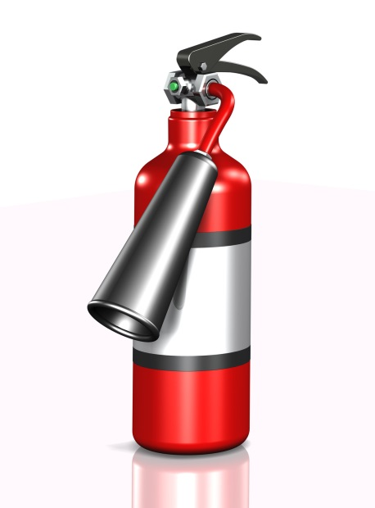
- Smoke only where allowed.
- Do not turn your back on hot fat, as it may burst into flames.
- Keep equipment and hoops from grease build up because grease causes many food service fires.
- Do not set the fryer at too high a temperature.
- Store matches in a covered container, away from heat.
- Keep garbage in covered container, away from heat.
- Store chemicals away from heat because many chemicals are flammable.

Floor Safety
Every employee is responsible for looking for and correcting floor hazards. Remember to warn others of the of the hazard and to watch their step.

When encountering a spill, find the source of the spill and correct it. The following steps should be followed:
- Do not leave the spill unattended.
- Do not allow people to pass through the spill.
- Call maintenance or have a fellow employee do it for you.
- Whenever a mop is used, a “Caution Wet Floor” sign must also be used.
- Remember to be extra careful during bad weather. Rain can increase the possibility of floor hazard, warn customers as they enter and exit the workplace to watch their step.

Major cause of food borne illness
- Food left in the danger zone of 41° to 135° for four or more hours. Keep all foods out of the danger zone of 41° to 135°.
- Keep hot foods hot, and cold foods cold.
- Handle foods quickly during delivery, and put refrigerated and frozen foods away as soon as possible.
- Sloppy personal hygiene habits will not be tolerated.
- Do not prepare food a day or more before serving.
- Do not serve food that is not completely cooked.
- Thaw foods in refrigerator, microwave, or under cold running water for not more than 2 hours, followed immediately by cooking.
- Avoid preparing food in advance, unless absolutely necessary.
- Inspect Foods thoroughly for freshness and wholesomeness upon receipt, cooking, and serving.
- Only use sanitized equipment and table surfaces.

Always wash your hands after you
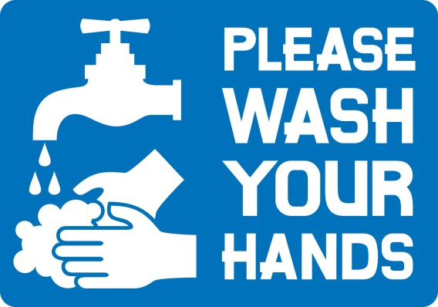
- Smoke, eat, use the restroom; touch money, raw foods, or your face, hair or skin; cough, sneeze, or blow your nose
- Comb your hair, handle anything dirty
- Before and after taking a break

Dispose of waste properly
- Take garbage out frequently.
- Keep garbage areas clean and sealed.
- Clean and sanitize garbage cans regularly.
- Store soiled linen in a laundry bag or non-absorbing container.

Keep insects and animals out by
- Keeping doors closed.
- Taking garbage out frequently and keeping garbage areas clean.
- Report any holes where an animal can enter.
- Do not provide a free meal for any animals.

Handle ice and tableware properly
- Use clean scoops to pick up ice, do not use hands or glass.
- Store scoops in a clean container, not in the ice.
- Do not store any food or beverage in the ice.
- Avoid touching food contact surface with dishes, utensils, etc.

Avoid cross contamination from one food item to another
- Keep separate cutting boards for raw and cooked foods.
- Never mix leftovers with fresh food.
- Store fresh raw meats, poultry, and fish on lowest racks.
- Sanitize thermometers after each use.
- When thawing raw foods in the refrigerator, place them on the lowest shelf.

Store foods and equipment properly
- Cover, label, and date foods in storage.
- Do not store food in open cans.
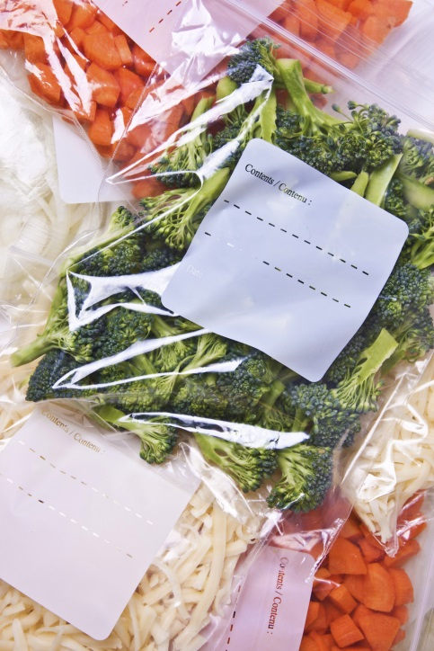
- FIFO – (First In , First Out) Store new foods behind old ones.
- Store food off the floor and away from the wall.
- Check temperatures of refrigerators and freezers daily.
- Defrost freezers as necessary. Frost build up causes freezers to warm up.
- Dry goods and storage areas should be cool and dry for good storage.
- Do not store food or equipment under exposed server lines.
- Keep storage areas clean.
- Store all equipment so that dust cannot settle on it.
- Store chemicals and pesticides separately from food.

When cleaning stationary equipment
- Unplug equipment, and make sure hands are dry.
- Disassemble.
- Wash removable parts in dish machine, or three-compartment sink.
- Wash and rinse stationary parts.
- Sanitize food contact surfaces with sanitizer.
- Air dry before reassembling, without touching food contact surfaces.

Preventing falls

- Wipe up spills immediately.
- Use "wet floor" signs.
- Wear shoes with non-skid soles and heels.
- Keep isles and stairs clear.
- Walk, and do not run.
- Follow established traffic patterns.
- Do not carry anything that blocks your vision.
- Keep drawers closed.
- Use ladders properly; never use chairs, tables or boxes. Do not stand on top of ladder, and do not over reach.
- Use handrails on stairs.
- Turn lights on to see.
- Never run in the kitchen. The floor may be wet.
- Never leave anything on the floor including ice from the ice machine.

Preventing electric shock
- Never touch electrical equipment with wet hands, or while standing in water.
- Unplug equipment before cleaning or disassembling, to avoid shock.
- Do not yank plugs out by cord. This can cause damage to the cords, which may then cause shocks.
- Report damaged and worn plugs and cords to your supervisor.

Lift Properly
- Plan it. Do you need help? Could you use a cart? Where is it going? Which route is best?
- Get ready. Spread feet apart, shoulder width. Put one food slightly in front of the other for a good support base. Squat down with back straight and head up. Do not bend over from the waist! Grip the object firmly with both hands. Keep elbows and arms close to body. Tuck in chin. If lifting a tray, squat down alongside the tray and slide the tray onto your shoulder and hand.

- Lift it! Straighten your knees slowly and smoothly to a stand. Avoid doing this in a quick or jerky manner. Do not lift and twist at the same time.
- Move it! Keep object close to you. To change position, move your feet and entire body. Do not twist from the waist. Look where you are going and call out "coming through" as needed.
- Set it down! Bend your knees slowly and smoothly. Slide load into place; watch your fingers and toes.

Moving a cart properly
- Push rather than pull.
- Spread feet wide, one in front of the other with your front knee bent.
- Keep back straight.
- Slowly push into the cart with your body weight, using your leg muscles to do much of the pushing.
- Push slowly and smoothly. Avoid sudden motions or twisting your back.

Preventing Cuts
- Pay attention when using sharp equipment. Never touch edges of sharp blades.
- Know how to operate equipment.
- Use guards when provided on equipment.
- Use tampers to push food into equipment.
- Turn equipment off before adjusting.
- No loose sleeves, ties, or dangling jewelry should be by equipment
- Use knives carefully.
- Carry dishes and glassware carefully.
- Sweep up broken glass; do not use your hands.
- Use special container to dispose of broken glass, dishes, and other sharp objects.
- Remove can lids entirely from cans, then dispose of them.

Preventing burns
- Pay attention when working around hot equipment.
- Use dry potholders or towels when handling hot equipment. Wet or moist towels will serve as conductors of heat.
- Keep pot handles turned in from the edge of the range and open flames.
- Avoid overfilling containers with hot foods.
- Get help lifting heavy pots of hot foods.
- Open lids of pots and doors of streamers away from you, and do so slowly, to avoid a steam burn.
- Stir foods with long-handled spoons.
- Warn others of hot surfaces.
- Let equipment cool before cleaning, and do not use wet rags.
- Do not put icy frozen foods into the fryer. Put foods slowly into the fryer and stand back to avoid being splattered.
- Strike match before turning on gas equipment, to avoid a flare-up.
- Wear closed-toe and closed-heel shoes that do not absorb liquids.
- Warn guest of hot dishes.

Safe chemical handling
- Do know where the material safety data sheets are posted, and read them.
- Do read the labels of all products, before you use them.
- Do follow the directions for proper storage, handling, and use for all chemicals you use.
- Do ask your supervisor any questions or concerns you may have about using a certain product.
- Do know how to call for medical help, in case of an emergency.
- Do not ever mix chemicals together.
- Do not store chemicals in unmarked containers.
- Do not store chemicals in or close to food storage, preparation, or serving areas.
- Do not leave aerosol spray containers near heat or spray close to an open flame.
- Do not dispose of any empty chemical container until you have checked on the label for how to do so.

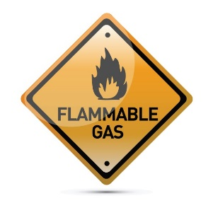
Reading the MSDS (Material Safety Data Sheets)
- Read product name.
- Fire hazard - explains if the product can catch fire or explode.
- Health hazards - explains effects of over exposure and first aid procedures.
- Spill precautions - explains steps to take in case of spills.
- Special protection - describes any special measures, such as goggles and rubber gloves, used to decrease exposure and risk.

Dress Code & Personal Hygiene

personal hygiene
- Arrive to work clean with: well-groomed hair, hair pulled back off the shoulder, clean clothing, teeth brushed, bathed and daily use of deodorant.
- Hair Guidelines: Hair must be clean and, if longer than shoulder length, swept cleanly off the face. The ends of the hair must be tightly secured without any loose strands. Hair may be braided, in a bun or secured with an additional hair accessory. Hair accessories should be small and neutral in color, black preferred. Please avoid extreme hair styles or colors.
- Appearance: facial tattoos and excessive facial piercing are not permitted. No facial piercing are permitted in the front-of-house. Do not wear false eyelashes.
- Well-groomed hands: Maintain short, clean, and polish-free fingernails. Fingernails should be trimmed, filed, and maintained so edges and surfaces are cleanable and not rough. No artificial nails are permitted in the food production area.
- Wash hands: (including under fingernails) and up to forearms vigorously and thoroughly with soap and warmwater for a period of 20 seconds, following Handwashing SOP.
- Cuts, abrasions and burns: Bandage any cut, abrasion, or burn that has broken the skin. Cover bandages on hands with gloves and finger cots and change as appropriate. Inform manager of all wounds.

Dining Room Dress Code
Shoes – Clean solid black shoes (no colored stripes or logos) designated by the manufacturer to be slip-resistant or skid resistant. Must be closed toe and closed heel (no clogs). Socks must be black.
Pants & Belts – Clean professional looking, wrinkle-free black slacks / pants (dry cleaning / creases not required). Pants must be long enough to cover shoe tops. Lycra / polyester stretch knit, corduroy and linen pants are not acceptable and may not be worn. No rolled cuffs and no large pockets. Black belt or no belt.
Shirts – All shirts must be clean and wrinkle free. Black Maple Leaf Diner T-shirt or solid black t-shirt that is not faded and at least medium-weight material. The material must be thick enough, so it is not transparent.
Accessories - No cologne or perfume No excessive make-up or jewelry. No earrings longer than 1 inch. No hat can be worn.
Apron – Maple Leaf aprons must be purchased for $15.

Kitchen Dress Code
Shoes - Clean solid black shoes (no colored stripes or logos) designated by the manufacturer to be slip-resistant or skid resistant. Must be closed toe and closed heel (no clogs). Socks must be black.
Pants - Clean professional looking, wrinkle-free black slacks / pants (dry cleaning / creases not required). Pants must be long enough to cover shoe tops. Lycra / polyester stretch knit, corduroy and linen pants are not acceptable and may not be worn. No rolled cuffs and no large pockets. Black belt or no belt.
Shirts - All shirts must be clean and wrinkle free. Black Maple Leaf Diner T-shirt or solid black t-shirt that is not faded and at least medium-weight material. The material must be thick enough, so it is not transparent.
Accessories - No excessive cologne or perfume. No excessive make-up. Refrain from wearing jewelry in the food production area to prevent physical and microbial contamination of foods. Only a plain wedding band. No necklaces, bracelets, or dangling jewelry are permitted. No earrings or piercings that can be removed are permitted.
Apron – Maple Leaf aprons must be purchased for $15.
Hats – Hats must be worn by back of house staff. All hats must be black, simple in design and in good condition, not soiled or stained.

Accidents and Emergency Situations
Report all accidents, no matter how minor they seem, to the manager on duty. In the event of an emergency, like an apparent injury or choking situation, notify a manager immediately. Managers are responsible for administering CPR, choking procedures or appropriate first aid.

Crime and Robbery
If you are ever involved in a robbery, DO NOT RESIST. Statistics show that people, who resist, are three times more likely to be injured than people who do not resist. The safety of you, your fellow employees and customers are our highest priority. Don’t be a hero, always cooperate fully and do not resist!

Fire Protection
All employees must know the specific location and operation of fire protection in the Restaurant. The Restaurant is equipped with many fire-extinguishing systems in the ducts, hood, over the stoves and other cooking equipment that contains a dry chemical. They can be set off immediately by pulling the ring attached to each system. We also maintain hand held CO² systems (behind the bar, in the kitchen, etc.) Be very specific before setting off a fire alarm or notifying someone to take action.
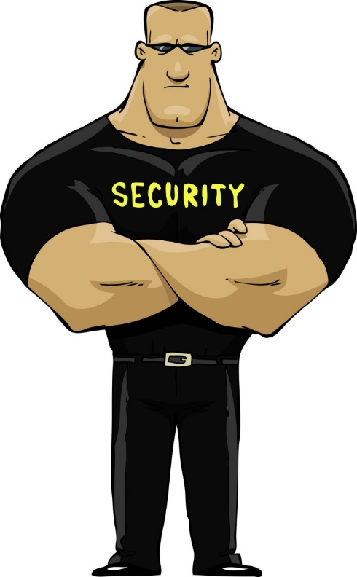
If the fire alarm sounds, assist guests to the nearest fire exit and out of the building immediately. Tell them the restaurant is under “Fire Alarm Status” and it is their responsibility to leave the restaurant through the nearest exit.

Alcohol Serving Policy
As a Restaurant that sells alcoholic beverages, we are committed to sensible, socially responsible consumption of alcohol. We help to ensure our customers’ and other members of the community’s safety by educating our employees on responsible service and management of alcohol. We want our customers to enjoy alcoholic beverages in moderation, but if a customer shows signs of drinking too much, a manager should become informed immediately.
Employees who serve customers, must abide by the Restaurant’s policies on alcoholic beverage service:
- We will not serve alcoholic beverages to an intoxicated person.
- We will not knowingly serve alcoholic beverages to a person under the legal drinking age. It is our policy to card anyone who appears to be under 30 years old.
- We will offer nonalcoholic alternatives such as soft drinks, coffee, juice, etc.

Lost and Found
All items found are turned into a Manager, or the Door personnel, and immediately listed in the Lost and Found Log. The Manager then places items in the Lost and Found area in the back office, as soon as possible.
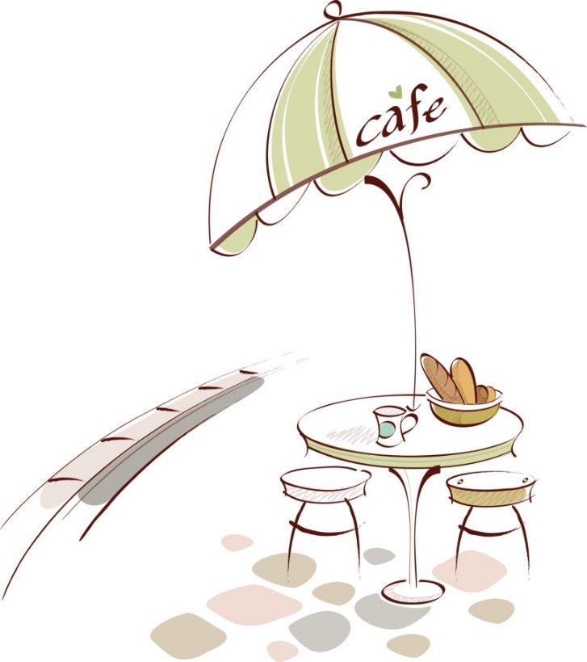
During operating hours, any inquiries made by a guest, regarding lost items, should be directed to the front door. A Manager or Host\Hostess will list any guest with a report of a lost item, along with its description, in the Lost and Found Log. This log should be returned to the back office at the end of the night.
The log is kept in the office during the day, so that the Office Manager may answer phone inquiries. The opening Host/Hostess will pick up the log at the beginning of the shift, so that they may answer and record inquiries. Articles found in the facility are kept for two weeks, and not claimed, will then be donated to a charitable organization.

Proprietary & Confidential Information
It is illegal to steal, copy or communicate or transmit a former employer’s confidential or proprietary information. Proprietary information is defined as “the whole or any part of any scientific or technical information, design, process, procedure, formula, or improvement that has value and that the owner has taken measures to prevent from becoming available to persons other than those selected by the owner to have access for limited purposes.” Our internal business practices, procedures and recipes are of great value to MLD. Employees are not to disclose any proprietary processes or recipes to any person unless directed to by MLD’s owner. MLD will institute civil action against anyone who violates this policy.

Solicitation

Employees
There should be no solicitation or distribution of literature of any kind by any employee during actual working time of the employee soliciting or the employee being solicited. Working time does not include lunch and rest breaks. Any employee who violates any part of this policy will be subject to counseling and disciplinary action up to and including dismissal.


Non-Employees
Non-employees are prohibited from soliciting and distributing literature at all times anywhere on Company property. Non-employees have no right of access to any area of the premises other than areas open to the public, and then only in conjunction with the area’s public use.

Cellular Phone Use Policy
MLD has adopted the following cellular phone use policy. This usage applies to any personally owned device capable of placing or receiving phone calls, messages, text or video messages, or with access to the internet or email.

Cell Phone Use for Business While Driving is Prohibited
MLD is aware that some employees use their cell phones for business purposes while driving in their personal or company vehicle. It is the opinion of MLD that cell phone use while driving is dangerous, therefore, the company prohibits employee use of any cellular phone, either hands on or hands free, for business purposes related in any way to our company, while driving. This prohibition includes receiving or placing calls, text messaging, surfing the Internet, receiving or responding to email, checking for phone messages, or any other purpose related to your employment; the business; our customers; our vendors; volunteer activities, meetings, or civic responsibilities performed for or attended in the name of the company; or any other company or personally related activities not named here while driving. When use of a cell phone is necessary, the employee shall park the vehicle in a manner consistent with traffic safety standards before placing or answering calls.

Cell Phones in the Restaurant - Management

MLD is aware that certain management level employees utilize their personal or company-supplied cellular phones for business purposes. At the same time, cell phones can be a distraction in the restaurant. To ensure the effectiveness of day-to-day management tasks such as directing employees, customer interaction, staff meetings and other job-related activities, management employees are asked to leave cell phones in the office unless otherwise permitted in this policy. Or, on the unusual occasion of an emergency or anticipated emergency that requires immediate attention, the cell phone may be carried in the restaurant as long as it is on vibrate mode.
The office is the preferred location for cellular phone use. Other acceptable areas are food, beverage and supply storage areas if necessary when placing vendor orders, or, outside the restaurant. Use of cell phones is prohibited in the dining room, bar or any place that is in view of the customer.
The recognized management level job positions for which the business use of cell phones is permitted for MLD are as follows:
- General Manager
- Dining Room Manager
- Kitchen Manager
- Event Manager

Cell Phones in the Restaurant - Staff
Non-management level employees are prohibited from cell phone use while at work. This prohibition includes receiving or placing calls, text messaging, surfing the Internet, receiving or responding to email or checking for phone messages. Cell phones are to be turned off upon arriving at the workplace unless otherwise permitted elsewhere in this policy.
The recognized staff level job positions for which cell phone usage is prohibited for MLD are as follows:
- Kitchen workers
- Servers
- Bartenders
- Bussers
- Hosts
- Dishwashers

Emergency Use of Cell Phones – Staff
MLD recognizes the fact many of their employees use a cell phone as a means for emergency notification by family, schools, hospitals and other persons or organizations for which emergency contact is necessary. Limited emergency use of cell phones is permitted under the following conditions
- Employees must obtain permission from management prior to use.
- Cell phones must be in vibrate-only mode.
- Cell phones must be left in the office or employee locker unless otherwise permitted by management.

Violation of Policy is Cause for Disciplinary Action
Employees who violate this policy will be subject to disciplinary actions, up to and including employment termination.


Sample Policy Regarding Supplier Gifts and Kickbacks

INTRODUCTION
Honesty and fairness are two components of MLD values—customer satisfaction, integrity and people. Our values, and company policies each require employees to make a committed effort to doing the right thing at all times, and to be honest and fair in all of their business dealings. Compromising those values and standards by offering or soliciting gifts or kickbacks is prohibited.

DEFINITION
A kickback is ANY money, fee, commission, credit, gift, gratuity, any item of value or compensation of any kind that is provided directly or indirectly, from an existing or prospective supplier for the purpose of obtaining or rewarding favorable treatment in the bidding, awarding or continuation of business with MLD.

RELATIONSHIPS WITH VENDORS/SUPPLIERS
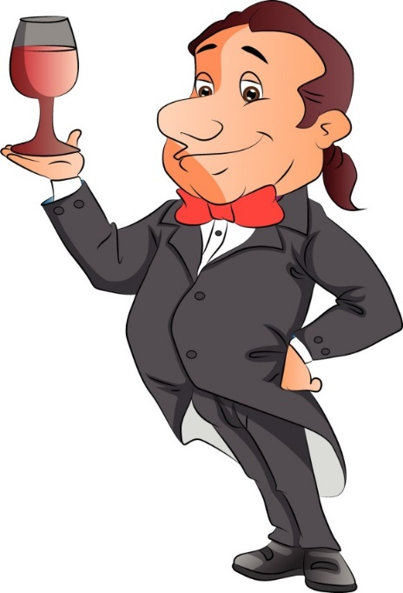
Relationships with suppliers of all goods and services to MLD must be on an “arms-length” basis, reflecting a willing buyer and willing seller. Whenever possible, competitive bidding should be used, with vendor and supplier decisions made on the basis of quality, price, availability and service.
If the employee making the purchasing decision is a friend or relative of the supplier, the employee should disclose this information to the manager, GM or owner before effecting the transaction.
Neither employees nor members of their immediate families may use a MLD supplier for personal needs on other than an “arms-length” basis.

KICKBACKS FROM VENDORS/SUPPLIERS
Employees of MLD are never to accept personal favors from existing or potential suppliers in exchange for our business. This would include items such as cash, loans, travel, lodging, invitations to attend sporting events, hunting trips, shows or other excursions in return for our business. Travel and lodging offered by vendors and suppliers may not be used for personal purposes, and under normal circumstances, employees should not accept invitations to attend major sporting or public events if the employee’s attendance is at substantial cost to suppliers and there is no significant business-related reason to attend.
Certain gifts and/or gratuities may be permissible in limited circumstances provided that they meet the criteria covered below.

GIFTS AND GRATUITIES
Meetings with vendors and suppliers may include some aspect of entertainment, provided the entertainment is of reasonable value and occasional frequency. The nature of meetings and entertainment should always be in good taste and not in conflict our values.
Participation in supplier-sponsored seminars, meetings or activities at vendor-owned or supplied facilities and attendance at other smaller sporting events may be permitted with prior approval by the GM or owner.

Handbook Receipt
This Employee Handbook does not constitute a contract of employment either in whole or in part. The Company, reserves the right to add, delete, or change any portion of the Employee Handbook with or without notice.
FOR THE EMPLOYEE’S INFORMATION:
Your employment status: ______ Full Time __Part Time
Your position title:
General Manager’s Name:
Your starting date:
I acknowledge receipt of, and have read, the Employee Handbook that outlines my benefits and obligations as an employee of MLD. I understand the Standards of Conduct and each of the rules and regulations which I am expected to follow, as well as the additional policies. I agree to abide by all of them.
All employees are expected to conform their conduct to the rules and regulations as set out in this handbook, and understand that they are at-will employees. The contents of any Employee Handbook, including this one, that may be distributed during the course of their employment shall not be construed to be a contract or in any way binding. The Company reserves the right to change, at its discretion, the contents of this handbook.
POLICY STATEMENT
This handbook is a general guide and provisions of this handbook do not constitute an employment agreement (contract) or a guarantee of continued employment. It is simply intended to outline the benefits and work requirements for all employees. It is further understood that the Company reserves the right to change the provisions in this handbook at any time. It is policy of the Company that employment and compensation of any employee is at will and can be terminated with or without cause, at any time, at the option of the employee or at the option of the Company.

Manager’s Signature |  | Date |  | Employee’s Signature |  | Date

